Name : …………………………………………………………… Admn. no ………..............................

School : ………………………………………………......…............. Candidate’s sign: .........................

Date : ……........……..............................................................…….

232
PHYSICS
(THEORY)
TIME: 2 HOURS

TERM 2 MID TERM 2 ASSESMENT EXAMINATION -2022

FORM 2
PHYSICS

INSTRUCTIONS TO CANDIDATES:
- Write your name, admission number, date of examination and the name of your school in the spaces provided above.
- Sign and write the date of examination in the spaces provided above.
- This paper consists of sections: A and B.
- Answer all the questions in section A and B in the spaces provided.
- All working must be clearly shown in the spaces provided.
- Mathematical tables and electronic calculators may be used.

For Examiner’s Use Only

SECTION | QUESTION | MAXIMUM SCORE | CANDIDATE’S SCORE
A | 1 – 12 | 25
B | 13
B | 14
B | 15
B | 16
B | 17
 | 18
TOTAL SCORE |  | 80
This paper consists of 8 printed pages. Candidates should check the question paper to ascertain that all the pages are printed as indicated and no questions are missing

SECTION A (25MARKS)
Answer all question this section
1. Distinguish between mass and weight of a body stating the S.I units for each. (2mks)
……………………………………………………………………………………………………..
……………………………………………………………………………………………………..
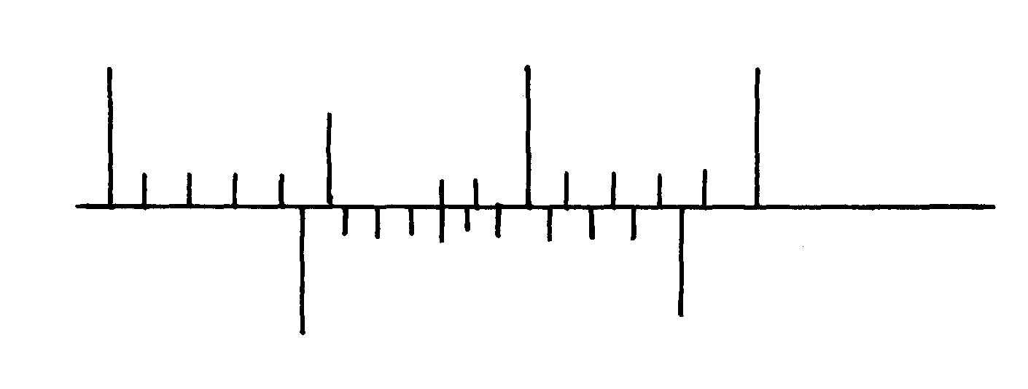
2. The figure below shows part of scale of vernier calipers.
7cm
8cm
0
10

What is the reading indicated on the scale ………………………………………….. (1mk)
3. 180cm³ of fresh water of density 100kg/m³ is mixed with 2200cm³ of sea water of density 1025kg/m³. Calculate the density of the mixture (4mks)

4. Explain why fish can survive under water when the surface is already frozen (2mks)
……………………………………………………………………………………………………..
……………………………………………………………………………………………………..
……………………………………………………………………………………………………..
……………………………………………………………………………………………………..
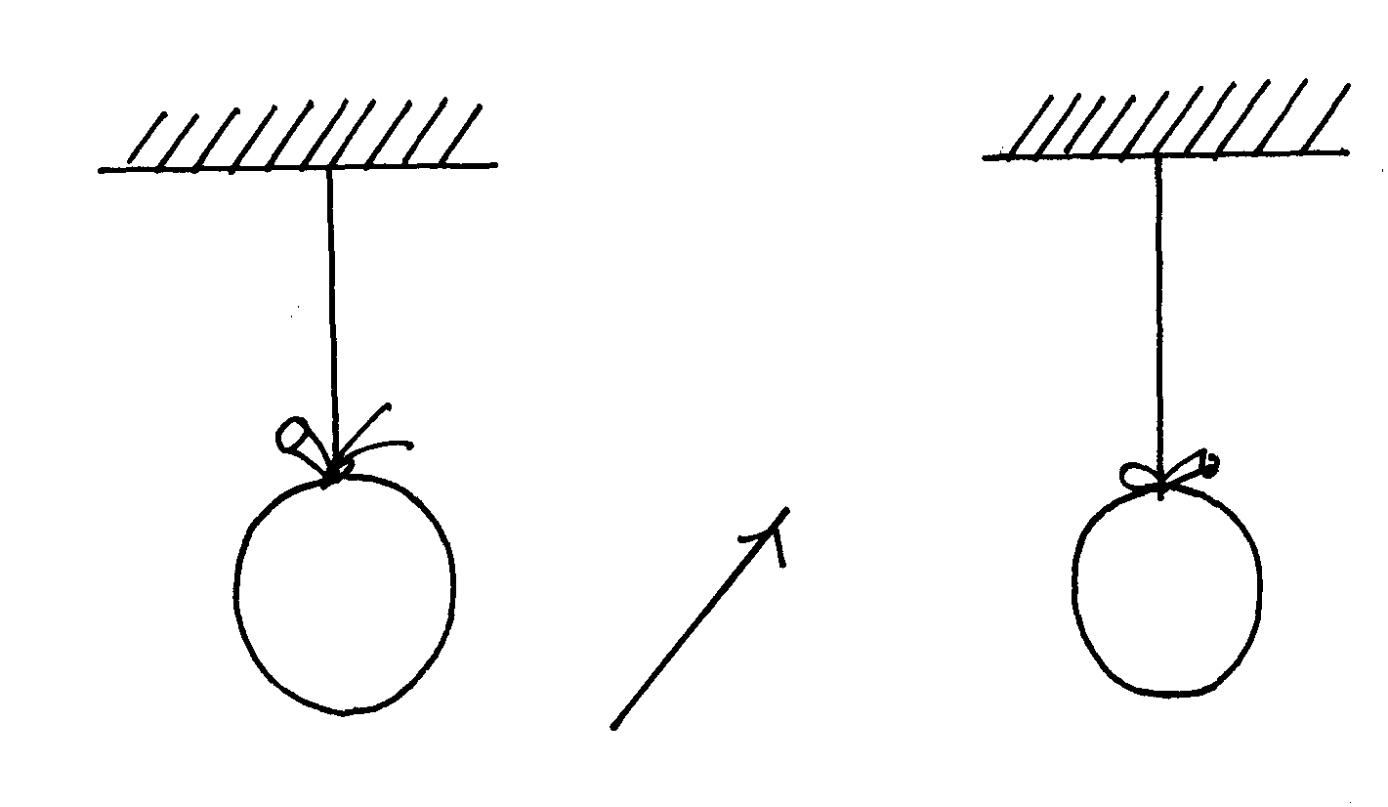
5. Two inflated balloons are at the same level while suspended from threads a short distance apart as shown below;
Air blown

Some air is blown gently in the space between the balloon in horizontal direction. Explain
what happens to the balloons. (2mks)
……………………………………………………………………………………………………..
……………………………………………………………………………………………………..
……………………………………………………………………………………………………..

6. State one advantage of an alkaline battery over a lead acid battery. (1mk)
……………………………………………………………………………………………………..
7. The diagram below shows a permanent magnet suspended by a spring. State with reason the behaviour of the magnet when the switch is closed. (2mks)
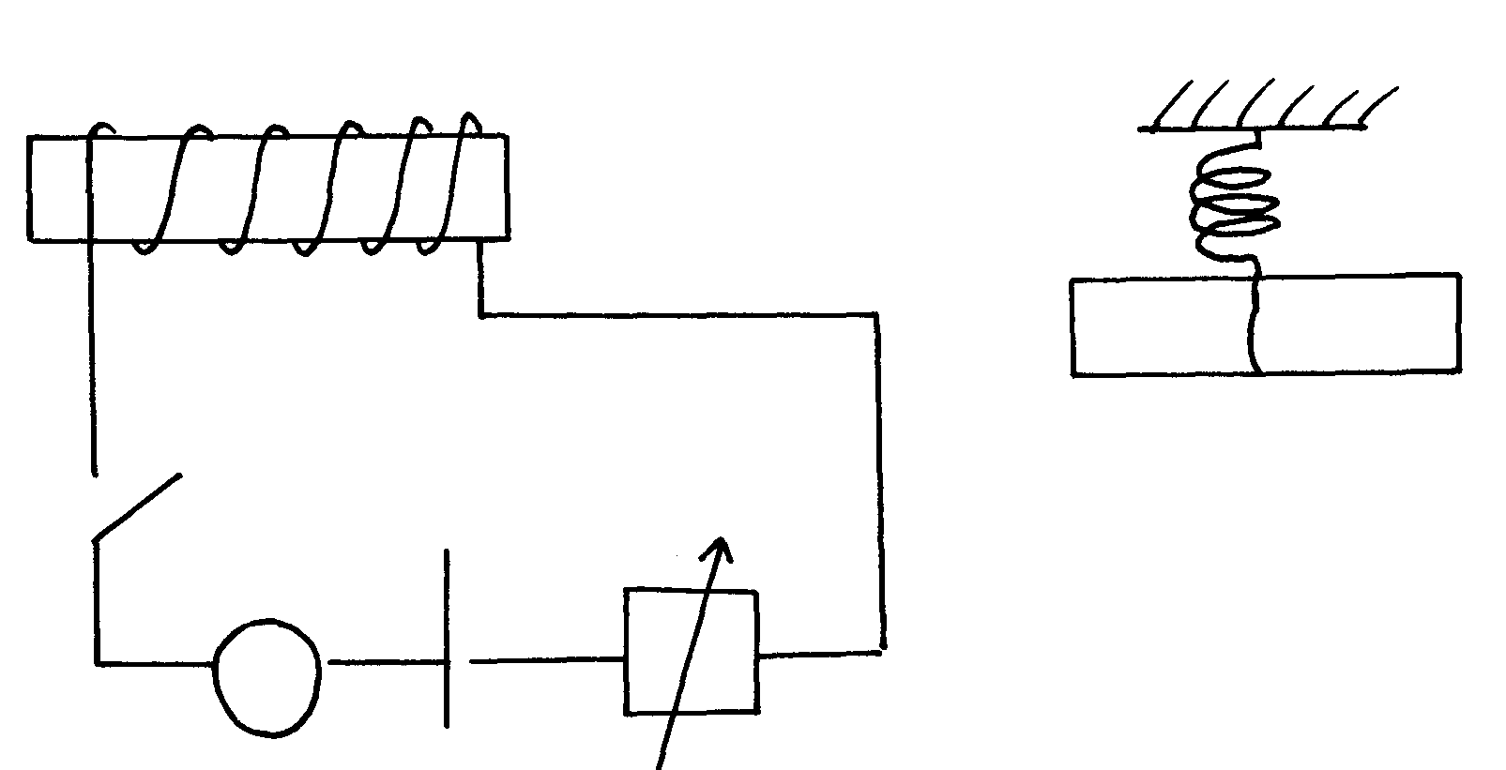
Spring
S
A
Y
N S
X
+ -

……………………………………………………………………………………………………..
……………………………………………………………………………………………………..
8. Convection and diffusion both involve motion of fluids. Distinguish between the two. (2mks)
……………………………………………………………………………………………………..
……………………………………………………………………………………………………..
……………………………………………………………………………………………………..
……………………………………………………………………………………………………..
9. A negatively, charged rod is brought close to (but not touching ) an uncharged sphere. If the
sphere is momentarily earthed and then the rod is removed, briefly explain what happens. (2mks)
……………………………………………………………………………………………………..
……………………………………………………………………………………………………..
10. Indicate on the diagram below, the level of mercury in the tubes X and Y (2mks)
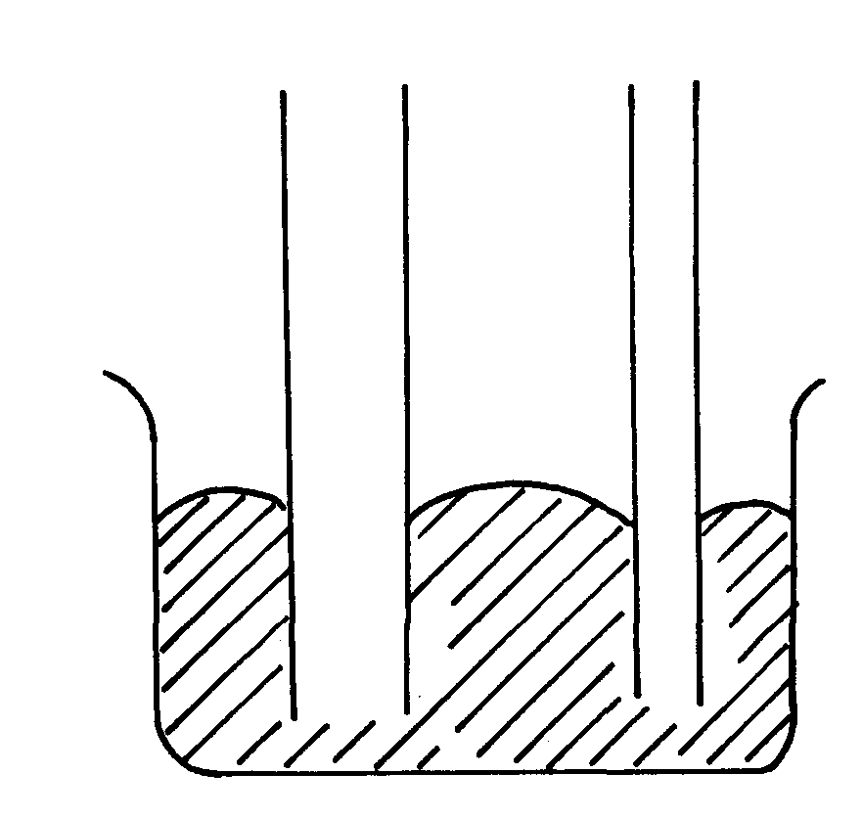
Mercury
X
Y

11. An object weighs 1200N on a certain planet. What is the gravitational field strength of this
planet if the object is 60kg? (3mks)

12. State two properties of a thermometric liquid. (2mks)
……………………………………………………………………………………………………..
……………………………………………………………………………………………………..
SECTION B (55MARKS)
Answer all question this section
13. (a) How does amplitude affect the loudness of musical note? (1mk)
……………………………………………………………………………………………………..
(b) What can be done to reduce echo in theatre halls? (1mk)
……………………………………………………………………………………………………..
(c) A girl stands some distance from a high wall and claps her hands;
(i) What two measurements would need to be made in order to determine the speed
of sound? (2mks)
……………………………………………………………………………………………………..
……………………………………………………………………………………………………..
(d) Describe how you would make use of these measurements. (3mks)
……………………………………………………………………………………………………..
……………………………………………………………………………………………………..
……………………………………………………………………………………………………..
……………………………………………………………………………………………………..
……………………………………………………………………………………………………..
……………………………………………………………………………………………………..
(e) A girl is standing between two cliffs A and B but nearer to cliff B than A. She stands
140m from wall B and shouts once. She hears two echoes and discovers that the time
between the two echoes is 0.6seconds. Determine how far the girls if standing from the
cliff given that the speed of sound in air is 340m/s. (3mks)

14. (a) State Hooke’s law . (1mk)
……………………………………………………………………………………………………..
……………………………………………………………………………………………………..
(b) The following readings were obtained when a spring was loaded gradually;
Load (N) | 0 | 10 | 20 | 30 | 40 | 50 | 60 | 70 | 80
Extension (cm) | 0 | 12 | 25 | 37 | 48 | 60 | 70 | 78 | 85

(i) Plot a graph of load (N) against extension (cm) (5mks)

 (ii) Mark on your graph the elastic limit P. (1mk)

(iii) Determine from the graph the elasticity constant of the material of the wire. (3mks)

15. (a) Distinguish between streamline and turbulent flow. (2mks)
……………………………………………………………………………………………………..
……………………………………………………………………………………………………..
……………………………………………………………………………………………………..
……………………………………………………………………………………………………..
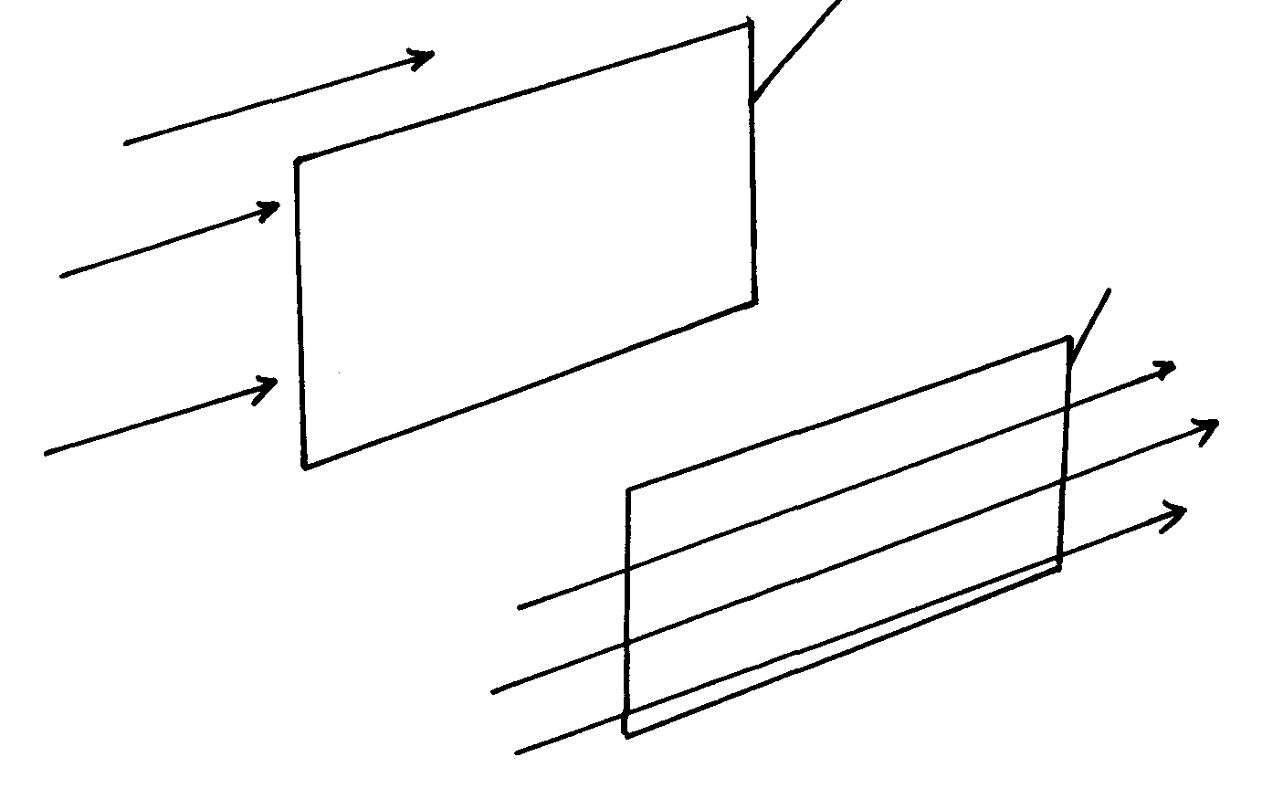
(b) The figure below shows two light sheets of paper arranged as shown;
Paper
Paper
B
A

Explain the observation made when air is blown at the same speed and at the same time
at point A and B. (2mks)
……………………………………………………………………………………………………..
……………………………………………………………………………………………………..
……………………………………………………………………………………………………..
(c) The diagram below shows an incompressible fluid moving through a tube of varied
cross-sectional area. If the area of the small tube is 0.055m², calculate the diameter
of the layer tube. (3mks)
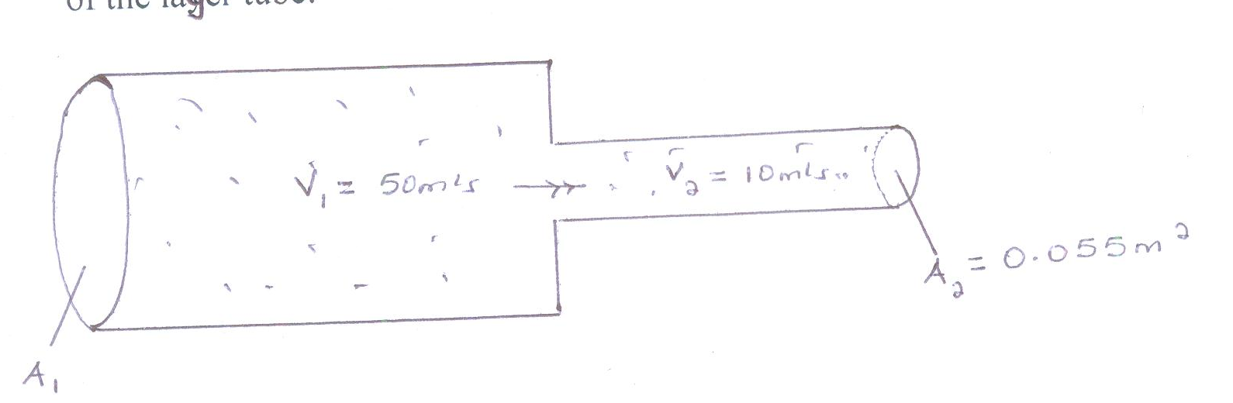

(d) Explain why a high speed jet has a sharp –nose shape (2mks)
……………………………………………………………………………………………………..
……………………………………………………………………………………………………..
……………………………………………………………………………………………………..
16. (a) Define pressure and give its S.I nits. (2mks)
……………………………………………………………………………………………………..
……………………………………………………………………………………………………..

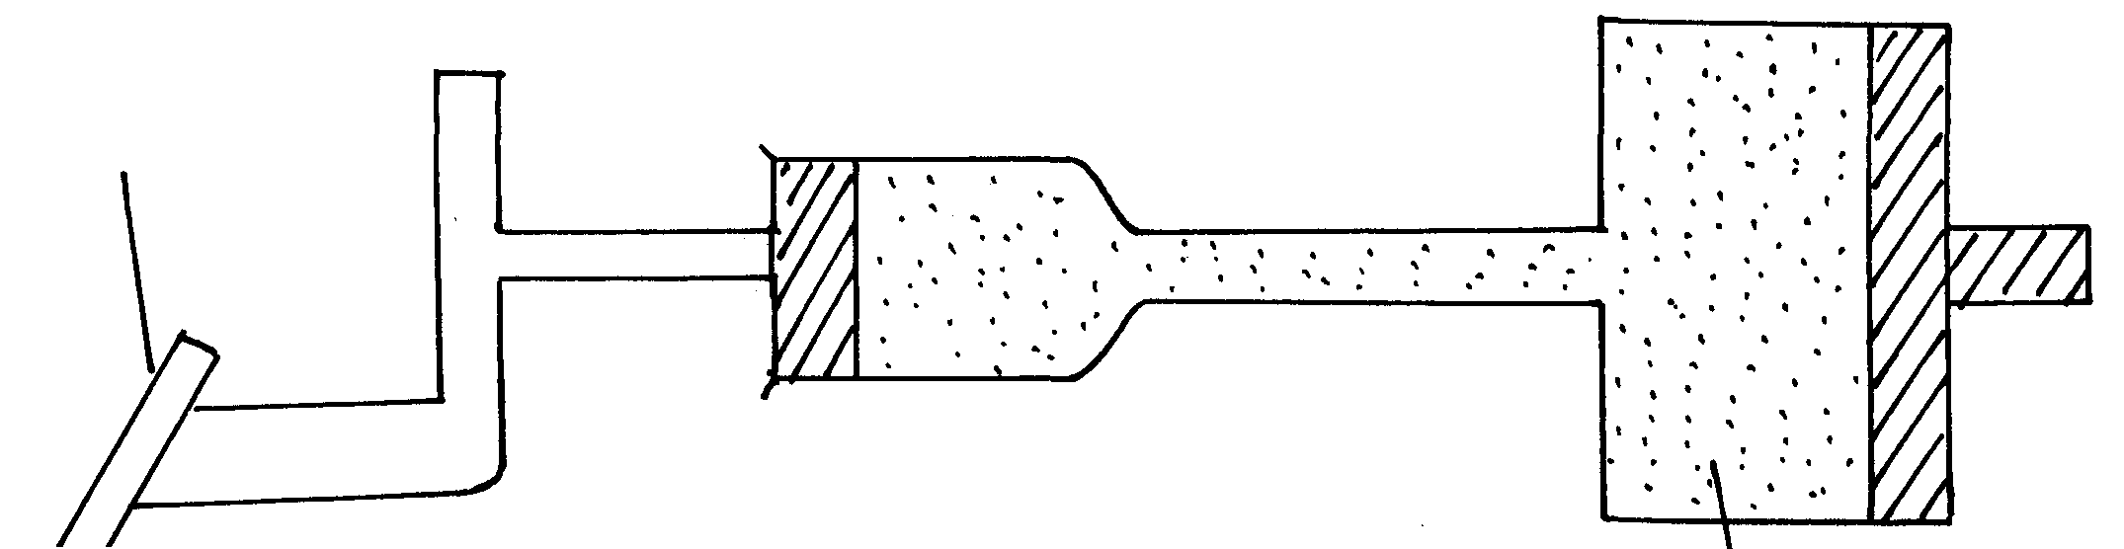
(b) The diagram below represents a motor car hydraulic braking system;
Brake pedal
Master piston
Slave piston brake fluid
B
A

(i)State two properties of the liquid used as a brake fluid (2mks)
……………………………………………………………………………………………………..
……………………………………………………………………………………………………..
(ii) Given that in the diagram (b) above the master piston has an area of 15cm² and the slave
piston has an area of 50cm² a force of 100N is applied on the master piston. Find the force
used to stop the car. (3mks)

(c) Compare the values of pressure in the two pistons above and give a reason for your
answer. (2mks)
……………………………………………………………………………………………………..
……………………………………………………………………………………………………..
(d) Give a reason why gas is not suitable for use in place of the brake fluid. (1mk)
……………………………………………………………………………………………………..
17. (a) Define centre of gravity. (1mk)
……………………………………………………………………………………………………..
……………………………………………………………………………………………………..
(b) State two factors affecting stability of a book. (2mks)
……………………………………………………………………………………………………..
……………………………………………………………………………………………………..
(c) Use simple sketches to show the three states of equilibrium. Name the states. (3mks)
……………………………………………………………………………………………………..
……………………………………………………………………………………………………..
……………………………………………………………………………………………………..
……………………………………………………………………………………………………..
……………………………………………………………………………………………………..
18. (a) Distinguish between a longitudinal wave and a transverse wave. (1mk)
……………………………………………………………………………………………………..
……………………………………………………………………………………………………..

(b) The figure below shows a displacement time graph of a wave. The velocity of the wave is 0.4m/s
0.05 0.10 0.15 0.20 0.25 0.30
0.4

0.2

0

-0.2

-0.4
Time (S)
Displacement (m)

Determine;
(i) The amplitude (1mk)
……………………………………………………………………………………………………..
……………………………………………………………………………………………………..
……………………………………………………………………………………………………..
……………………………………………………………………………………………………..
(ii) The period (1mk)
……………………………………………………………………………………………………..
……………………………………………………………………………………………………..
……………………………………………………………………………………………………..
……………………………………………………………………………………………………..
(iii) The wavelength (2mks)
……………………………………………………………………………………………………..
……………………………………………………………………………………………………..
……………………………………………………………………………………………………..
……………………………………………………………………………………………………..
……………………………………………………………………………………………………..
……………………………………………………………………………………………………..
……………………………………………………………………………………………………..
(c) State one disadvantage of a convex mirror when used as a car driving mirror (1mk)
……………………………………………………………………………………………………..
(d) What property of light is suggested by the formation of shadows? (1mk)
……………………………………………………………………………………………………..

