PHYSICS 232 MARKING SCHEME

1. Mass is the quantity of matter in a body while weight is the measure of the pull of gravity on the body.
weight S.I unit Newtons (N ) (½mk)
mass S.I unit Kilogram(kg) (½mk)

2. Main scale reading = 7.4cm
Vernier scale reading = 4x0.01 = 0.04cm
Total reading = 7.4 + 0.04 = 7.44 cm (1mk)

3. Density of mixture = mass of mixture
Volume of mixture
Mass of fresh water = 1800 x 1 =1800g
Mass of sea water = 2200 x 1.025 = 2255g
Density of mixture = 2255 + 1800
1800 + 2200
= 1.01375g/cm³

4. Ice being less dense than water, floats on water. Water at 4ºC being the most dense, remains at the bottom of the lake and aquatic life survives.

5. The two balloons move towards each other. On blowing air between the balloons, the speed of air increases and pressure reduces. The high atmospheric pressure on the sides pushes the balloons towards each other.
6. Large currents can be drawn from them
They can be kept in a discharged condition for a very long time before the cells are ruined
They require very little attention to maintain
They are lighter (portable) than lead-acid accumulators
7. The magnet towards on passing the current on the coil, the core XY is magnetized with the South Pole on Y thus attracting the North Pole of the permanent magnet.
8. Convection is the transfer of heat through fluids
Diffusion – is the process by which particles spread from regions of high concentration to those of low concentration.
9. The sphere acquires a positive charge by induction method.
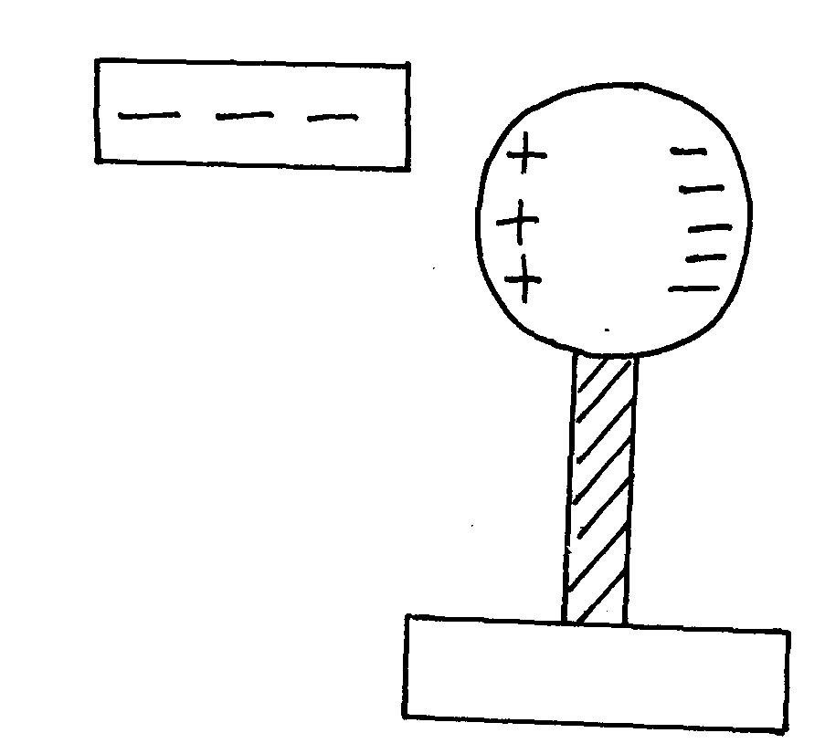
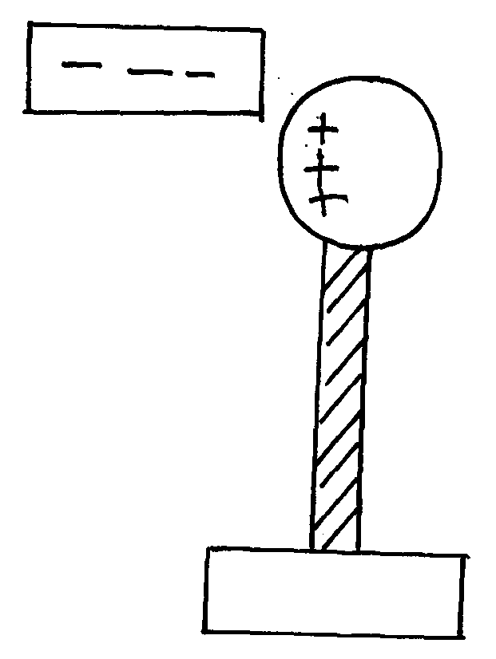
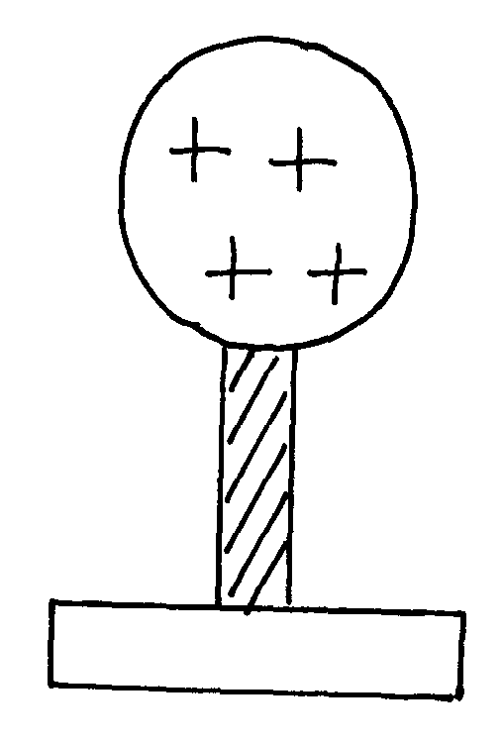
Negative charge to the ground

Earthing

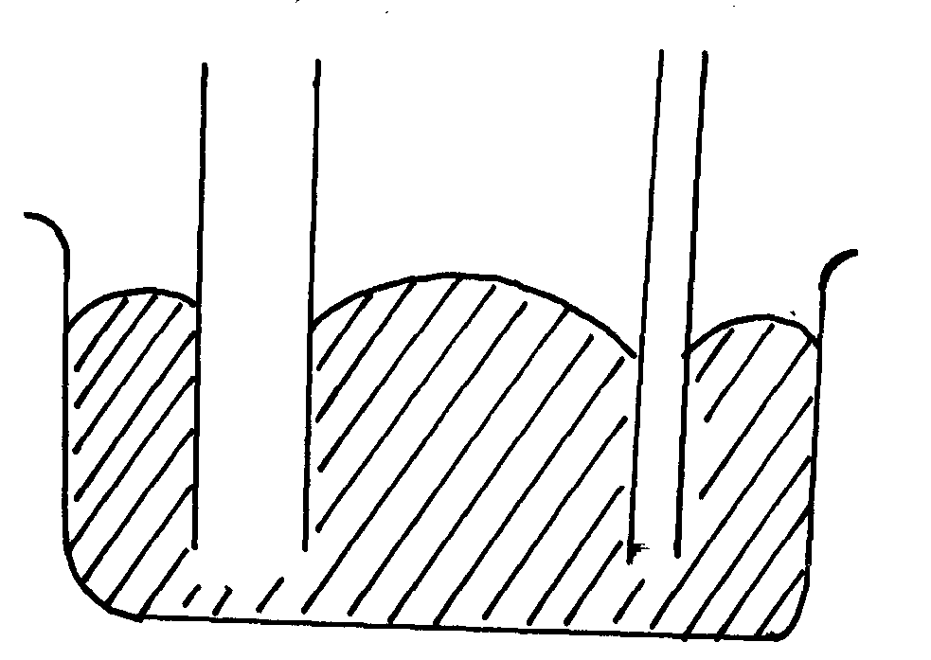
X Y
Y – is lower than x

10.

11. w-Mg
1200 = 60xg
g = 1200 = 20N/Kg
60
12. -Easily visible
-Expand or contract uniformly
-Have a wide range of temperature
-Not stick to the walls of the glass

Section B
13. (a) the higher the amplitude the louder the sound
(b) Use of sound absorbent materials on walls
(c) (i) Time taken for n number of claps . the distance between the girl and the walls.
(d) Sound has to travel to the walls and reflected back to the girl
Distance traveled is 2d;
For n claps there will be n echoes
140m
140 - x
x
Total distance traveled = n x 2d = 2nd
Speed = 2nd;
t
(e)

t₁ – t₂ = 0.6
2x – 2(140-x) = 0.6
340 340
2x – 280 + 2x = 0.6
340
4x = 444
x = 11m

14. (a) (i) The extension of a spring is directly proportional to the force applied provided the elastic limit is
not exceeded.
(ii) elasticity constant , k = f/e = gradient
= 50 – θ
60- 0
= ⁵⁰/₆₀
(b)
= 0.833N/cm
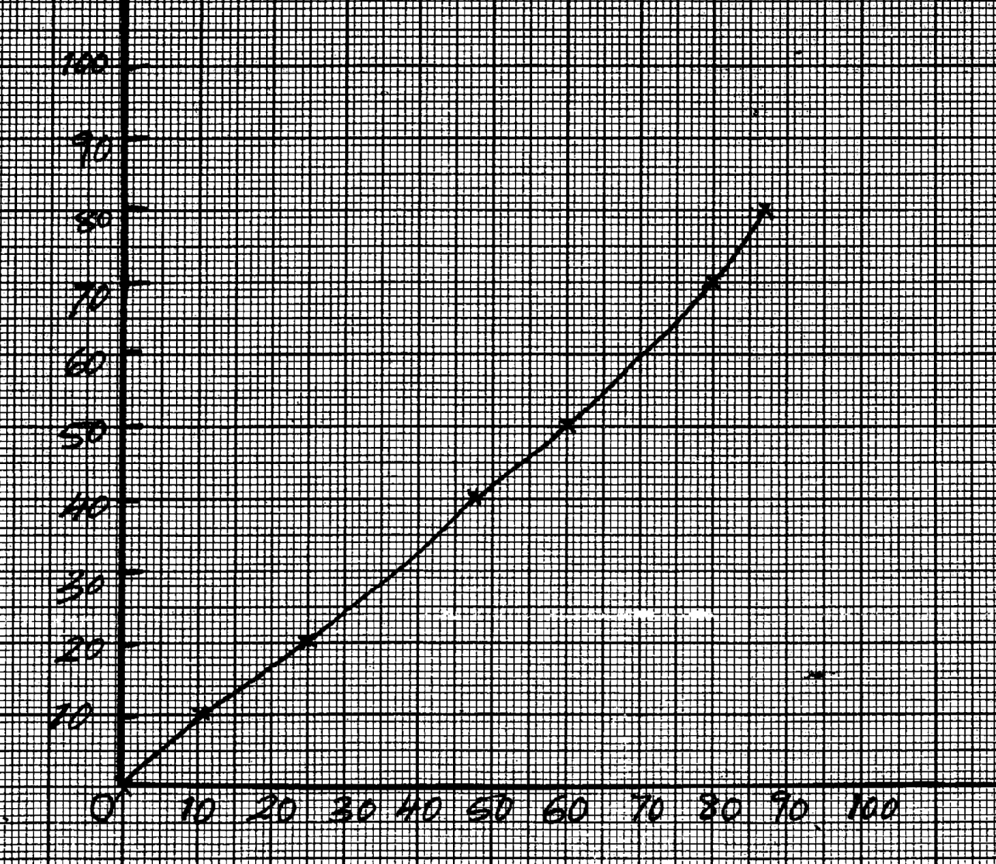
Axes – 1mk
Scale – 1mk
Plotting – 9pts – 2mks
6-8 pts = 1mk
Less than 6pts -0
Line/curve - 1

Load (N)

Extension (cm)

15. (a) Streamline flow- spread and direction of fluid particles passing any point do not vary with time.
turbulent flow – sped and direction of flow particles passing any point vary with time.
(b) The sheets more outwards from each other. Pressure at A and B reduces because air velocities at these points are high
(c) A₁V₁ = A₂V₂
A₁ x 0.1 = 0.055 x 2.2
A₁ = 1.21m²
A = πr²
r² = ^{A}/_{π}
= 1.21
π = 0.6205 D= 1.241m
(d) It enables the jet cut through the fluid with least resistance thus facutating streamline flow.

16. (a) Pressure is force per unit area S.I unit is N/m² or Pascals.
(b) (i) -incompressible
-Low freezing point
-High boiling point
-Should not corrode the parts of the brake system
(ii) P_{A} = P_{B}
F₁ = F₂
A₁ A₂
100 = F₂
15 50
F2 = 333.3 N

(c) P_{A} = P_{B}
Pressure in liquids is transmitted equally in all directions.
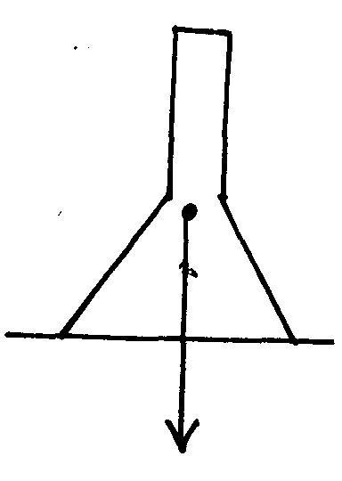
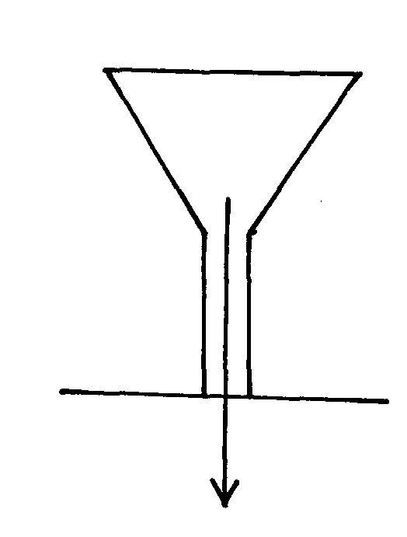
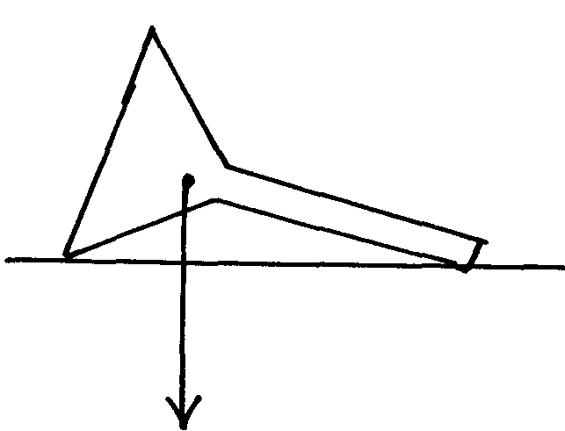
(d) Gas is compressible in liquid is incompressible.
C.O. G
C.O. G
C.O. G

- (c) (i) Stable equilibrium

(ii) unstable equilibrium

(iii) neutral equilibrium

(a) It s the point of application of the resultant force due to the earth’s attraction n the body.
(b) Base area
Position of C.O.G
Vertical line drawn from C.O.G

18. (a) Longitudinal wave- particles of the medium vibrate parallel to the direction of travel of he wave.
Traverse wave - Particles of the medium vibrate at right angles to the direction of the crave.
(i) amplitude = 0.4m
(ii) T = 0.20seconds

(iii) V = 0.4m/s
λ = ?
F= ¹/_{T}
= ^{1/} _{0.2}
= 5Hz
V =fλ
0.4 = 5 x λ
λ = ^{0.4}/₅
= 0.08m

(c) It makes it difficult for a driver to judge the distance when reversing the car since the distances
involved are distorted.

