MATHEMATICS FORM TWO
MARKING SCHEME.
1. | 0.015 + 0.45 ÷ 1.5  4.9 x 0.2 + 0.07  = 0.015 + 0.3  0.98 + 0.07  = 0.315  1.05  = 0.3 | M1  M1  A1 | Order of operation in num  Order of operations in den for 0.3 N or 3/10
 |  | 3mks
2. | Exterior angle 180 – 156 = 24  No of sides = 360  24  = 15 sides | M1  A1 | Expression for no. sides  Total no. sides
 |  | 2mks
3. | a² – b² = ( a + b) ( a – b)  63.7² – 36.3²  = ( 63.7 + 36.3) (63.7 – 36.3)  = 27.4 x 100  = 2740 | B1  M1  A1 | CAN BE INFERED IF SEEN
 |  | 3mks
4. | 7 x 100 = 29.17 %, 5 x 100 = 31. 25 %  24 16  3 x 100 = 37.5 %, 9 x 100 = 28.13 %  8 32  ¼ x 100 = 25 %  ¼ , 9/32, 7/24, 5/16, 3/8 | M1  A1 | 0.29, 0.31,0.38,0.28,0.25
 |  | 2mks
5. | Total number of hrs  Taken = ( 24 + 24 + 24 + 6) hrs  Time = 78hrs  Lost = ( 78 )x6 minutes = 19.5min  24  ∴ current time should be:  6:00 + 19.5  = 6: 19.5 pm | M1  M1  A1
 |  | 3mks
6. | 9 + 3 ÷ 5 of 12  4 4 6 5  1  2  = 9 + 3 ÷ 5 x 12  - 4 6 5  1  1  = 9 + 3 x 1 = 9 + 3 = 21  4 4 2 4 8 8  5  = 21 x 10 = 105  8 17 68  4  = 1 37  68 | M1  M1  M1  A1 | Operator on  Order of operation  Multiplication by 10  17  C.A.O
 |  | 4mks
7. | No Log  - 0.9070  ( 0.7432)^{½} + ī.8711  2  Ī .9356 2. + 1.8711  2  ( 0.824)² 0.8426  Ī.8318 ī.9159  x 2  1.0252 x 10¹ 1.0108  = 10.252 | M1  M1  M1  A1 | All the logs ✓ read ( 0.99070, ī.8711 , ī.9159)  Attempt to divided by 2  Attempt to ad/subtract✓ by
 |  | 4mks
8 | 64 ^{-½} x 2700 ^{2/3}  2⁻⁴ x 3⁰ x 5²  = 1/8 x 900  1/16 x 1 x 25  = ( 900 ) ÷ ( 25)  - 10  2  = 900 x 16 = 36 x 2 = 72  5  8 25 | M1  M1  M1  A1 | 1/8 x 900 ( expression)  3⁰ = 1 ( simplified)
 |  | 4mks
9. | 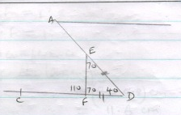 | B 1  B1  B1 | ∠ ADF = 40º  Accept angles marked on the diagram  180 – 40 = 70º  2  180 – 70 = 110º
 |  | 3mks
10. | ∠ ADF = 180 – 60 = 120º  ∴ ACB = 120  2  = 60º | B1  M1  A1 | for angle 120º  accept the angles marked on the diagram.
 |  | 3mks
11. | L =√ 36 + 25  1 4  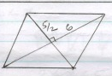  = √ 169 = 13 = 6.5  - 2  ∴ perimeter = 4x6.5  = 26 cm | M1  A1  M1  A1
 |  | 4mks
12. | Volume of hemisphere ( ⁴/₃ x π x 12³ x ½ )  ⁴/₃ x π x 12³ x ½ = ¹/₃ x π x 6² x h  h = 96cm | M1  M1  A1 | Expression for hemisphere  Equating the two
 |  | 3mks
13. | Grad of AB = 10-6 = 4 = 1  12-4 8 2  Grad of 1 = -2……….  Mid point of AB ( 8,8)  ∴ y = mx + c  y= -2x +c  y= -2x + 24 | M1  M1  A1 | Alternatively  -2 = y – 8  x -8  y-8 = -2x + 16  y = -2x + 24  8 = -16 + c  C = 24.
 |  | 3mks
14 | v.s.f = 1: 8  l.s.f = 1: 2  circumference of the larger jug  = ( 2 x 5.8 ) cm  = 11.6 cm | M1  M1  A1 | L .S.F  Expression for cicemfrence
 |  | 3mks
15. | 2x + 1 < 11  2x < 10  x < 5  11 < 6x – 1  12 < 6x  2 < x  2 < x < 5  2 3 4 5 | B1  B1  B1 | Inequality  Inequality.  Combined solution.  Accept listed values i.e 3, 4  alternatively
 |  | 4mks
16 | Area of one Δ = ½ x 5 x 5 sin 60  cross- sectional area = 6 x ½ x 5 x 5 x sin 60  Volume = 20 x 6 x ½ x 5 x sin 60  = 1299.04 ( 2dp). | M1  M1  A1 | 7.5 x 2.5 x 2.5 x 2.5  6 x 10.83  20 x 6 x 10.83  Accept ( 1299.6)
 |  | 4mks
17 | 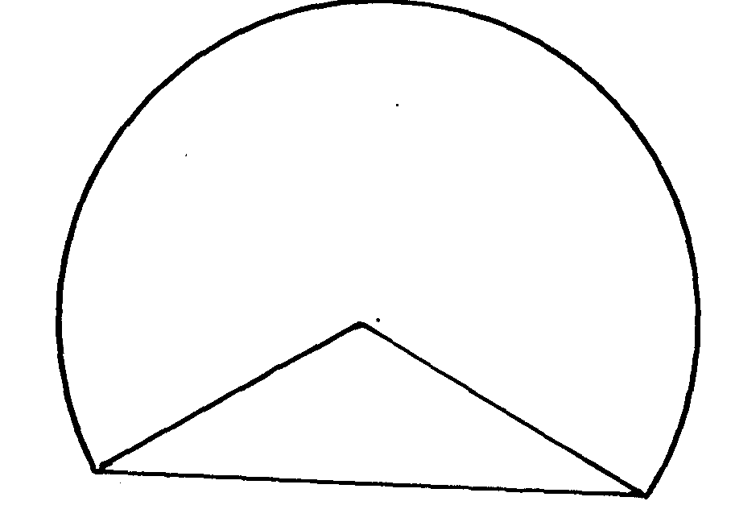  a)  Sin x = 4.5  6cm  6cm  9 cm  x  6  x = 48.59  ∴ ∠ AOB = 97.18º  Area of the mirror segment  = 97.18 x π x 6 x 6 – ½ x 6 x 6 sin 82.82  360  (30.54)(30.53) (12.68)  = 30.52 – 17.86 = 12.66  Area of the major segment  = ( 22 x 6 x 6 ) – 12.66  7  = 113. 14 – 12.66  = 100.48  b) A = √ 13.5 ( 6.5) (4.5) ( 2.5)  = 31.42 cm² | M1  A1  M1  M1  A1  M1  A1  S = 13.5  ✓ substitution in the formula  M1  M1  A1 | “Follow through”  And award marks appropriately
 |  | 10mks
18. | (i) x + 3y = 15  3  (ii) x – y = 4  3  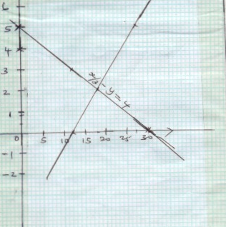 | B2  B2  S1  P1  P1  L1  L1  B1 | For any 3 correct pairs given  B1 if only two given  For any 3 correct pairs given  B1 if only two are given  Scale used  Plotting  Plotting  Line drawn  Linde drawn  Line drawn  Co-ordinate of the point of intersection  ( 18,2) or stated  X = 18,y=2 b1
  x | 0 | 12 | 30
  y | 5 | 3 | 0
  x | 12 | 18 | 27
  y | 0 | 2 | 5
19 | (a) (i) Kiptoo’s old salary  = ( 100 x 22400)  112  = sh 20,000.  - K: M = 5: 3  ³/₅ x 20,000 = sh. 12,000  b) Mary’s salary after the increase  36200 – 22400 = sh 13,800.  c) Increase in Mary’s s salary  = 13800- 12000  = 1800  ∴ % increases 1800 x 100  12000  = 15 %  d) New ratio  22400: 13800  112 : 69  e) Combined % increase  4200 x 100 = 13.125 %  32000 | M1  A1  M1  A1  B1  M1  A1  M1  A1  B1 | Expression for Kiptoo’s old salary  CAO  Expression for Mary’s salary  CAO  Increase in shillings  Accept.  69 : 112 ( simplified)
 |  | 10mks
20 | a) Total mass 5 boys = ( 5 x 54.4) = 272kg\  Total mass of the 8 boys  = ( 272 + 52 + 55.1 + 57.5) kg  = 436.6 kg  Mean mass = ( 436.6 ) = 54.575 kg  8  b) Modal class 30 – 34  x = 2015  60  = 33.58  c)  Md = 29.5 + (15 x 5)  18  = 29.5 + 4. 17  = 33. 67 | M1  M1  A1  B1  M1  A1  M1  A1 | Expression for mean  CAO  Fx column  Cf column  Expression for the median
  x | f | fx
  22  27  32  37  42 | 5  10  18  15  12 | 110  270  576  55  504
   | 60 | 2015
  x | f | cf
  20- 24  25- 29  30 - 34  35 - 39  40 - 44 | 5  10  18  15  12 | 5  15  33  48  60
   | 60 | 2015
 |  | 10mk
21 | a) volume of the sphere  = 4 x π x 8.4 x 8.4 x 8.4  3  ⇒ 4 x π x 8.4 x 8.4 x 8.4 = π x 12 x 12 x h.  3  h = 4 x 8.4 x 8.4 x 2.8  12 x 12  = 5.488cm  ∴ New height of water  5.488 + 10  = 15.488 cm  b) volume = 4 x 22 x 8.4³  (i) 3 7  = 24 83.712cm³  ∴ density = 100  2483.712  = 0.04026 g/cm³  ii) ( 8 x 2483.71)  = 19869 cm³ | M1  M1  M1  A1  B1  M1  A1  M1  A1 | Volume of the solid  Expression for vol. in the cylinder  Equating the two expression  Expression for h.  CAO
 |  | 10mks
22. | x² + y², x + y = 3  a) (i) x² 2xy + y² = ( x +y)² = 3² = 9  (ii) x² + 2xy +y² = ( x+y)² = 9  29 + 2xy =9  2xy = 9 – 29 = -20  - x² – 2xy + y² = x² + y² –( 2xy)  = 29 – ( -20)  = 49  - ( x-y) 2 = 49  x-y = ± 7 or – 7  b) x - y = 7  x + y = 3  2x = 10  x= 5, when x = 5, y = -2  or alternatives  x- y = -7  x + y = 3  2x = -4  x = -2  -2 – y = -7  - y = -5  y= 9  c) When x = -2,  4 – 2 k + 8 = 0  -2k = -12  K = 6  Equation x 2 + 6x + 8 = 0  (x + 2) ( x + 4) = 0  x – 2 or -4 | B1  B1  B1  B1  B1  M1  A1  B1  B1
 |  | 10mks
23. | h  30º  20º  X  500m  Tan 30º = h  χ  h= χ tan30º  tan 20º = h  ( 500 + x)  h=b( 500 + x) tan 20º  x tan 30 = 500 tan 20º + x tan 20º  x tan 30º – x tan 20º = 500 tan 20  x = 500 tan 20  tan 30 – tan 20  = 181.99 = 319.99  0.5689  ∴ h = 500 tan 20 ( tan 30)  tan 30 – tan 20  = 181.99 ( tan 2)  0.5689  = ( 298.45) | M1  M1  M1  A1  M1  A1 | Expression in height  Expression in height  Equating the two values of hi
 |  | 6mks
24. | w  15.2  62  28º  d  Sin 28º = w / 15.2  W = 15.2 sin 28  = 7.136 cm  Sin 62 = ι  15.2  l= 15.2 sin 62  = 13.42 cm  b) area of the rectangle  =7.14 x 13.42  = 95.8188  c)  40  70  70  ½ x a xa sin 40 = 128.56  a² = 2 x 128.56  sin 40  a = √2x 128.56  sin 40  = 20  ½ x 20 x sin 70 = 128.56 = 128.56  10 sin 70 9.3970  = 13.681  Sides 20,20, 13.681 | M1  A1  M1  A1  M1  A1

