Name: …………………………………………………. Adm. No: ……………………………………..
School: ……………………………………………..……. Candidate’s Signature: ………………………
Date: ……………………………………………………….

MATHEMATICS
TIME: 2 ½ HOURS

SCHOOL BASED ASSESMENT EXAM

FORM 2
MATHEMATICS

INSTRUCTIONS TO CANDIDATES:
- Write your name, admission number and school in the spaces provided above.
- This paper consists of two sections; I and II
- Answer all the questions in section I and any five questions in section II in the spaces provided.
- All working must be clearly shown in the spaces provided.
- Electronic calculators and KNEC mathematical tables may be used.

FOR EXAMINERS’ USE ONLY:
Section I
Questions | 1 | 2 | 3 | 4 | 5 | 6 | 7 | 8 | 9 | 10 | 11 | 12 | 13 | 14 | 15 | 16 | TOTAL
Marks

GRAND TOTAL
Section II
Questions | 17 | 18 | 19 | 20 | 21 | 22 | 23 | 24 | TOTAL
Marks
GRAND
TOTAL

This paper consists of 12 printed pages. Candidates should check to ascertain that all the papers are printed as indicated and that no questions are missing.
SECTION I (50 MARKS)
Answer all the questions in this section in the space provided.

1. Without using logarithm tables or a calculator evaluate.
0.015 + 0. 45 ÷1.5
4.9 x O.2 + 0.07 giving the answer in decimal form. (3mks)

- The size of an interior angle of a regular polygon is 156º. Find the number of sides of the
polygon. (2mks)

3. Factors the expression a² – b² (1mk)

Hence find the exact value of 63.7² – 36.3² (2mks)

4. Arrange the following fractions in ascending order 7, 5 , 3, 9, 1 (2mks)
24 16 8 32 4

5. A clock loses 6 minutes in every 24hours. If it is showing the correct time at mid- day on Monday. What is the correct time on Thursday when the clock shows 6.00p.m (3mks)

6. Without using a calculator evaluate 2 ¼ + ¾ ÷ ⁵/₆ of 2 ²/₅ leaving the answer as a
1⁷/₁₀ fraction in its simplest form (4mks)

7. Use logarithms to evaluate 8.072 X (0.74 32) ^{½} (3mks)
(0.824)²

8. Evaluate 64^{– ½} X 27000 ^{⅔} (4mks)
2⁻⁴ X 3⁰ X 5²

9 In the figure below line AB is parallel to line CD; angle BAD = 40º and Line DE = DF
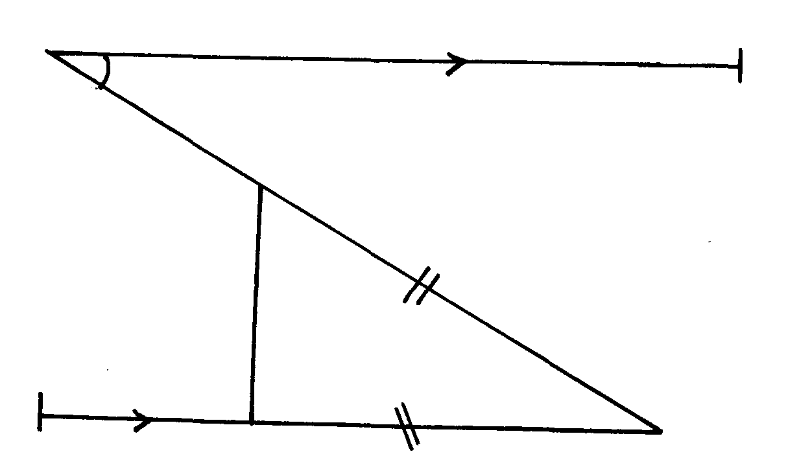
A
B
D
C
E
F
40º

Calculate the size of angle CFE (3mks)

10. In the figure below O, is the centre of the circle and angle OAB = 30º
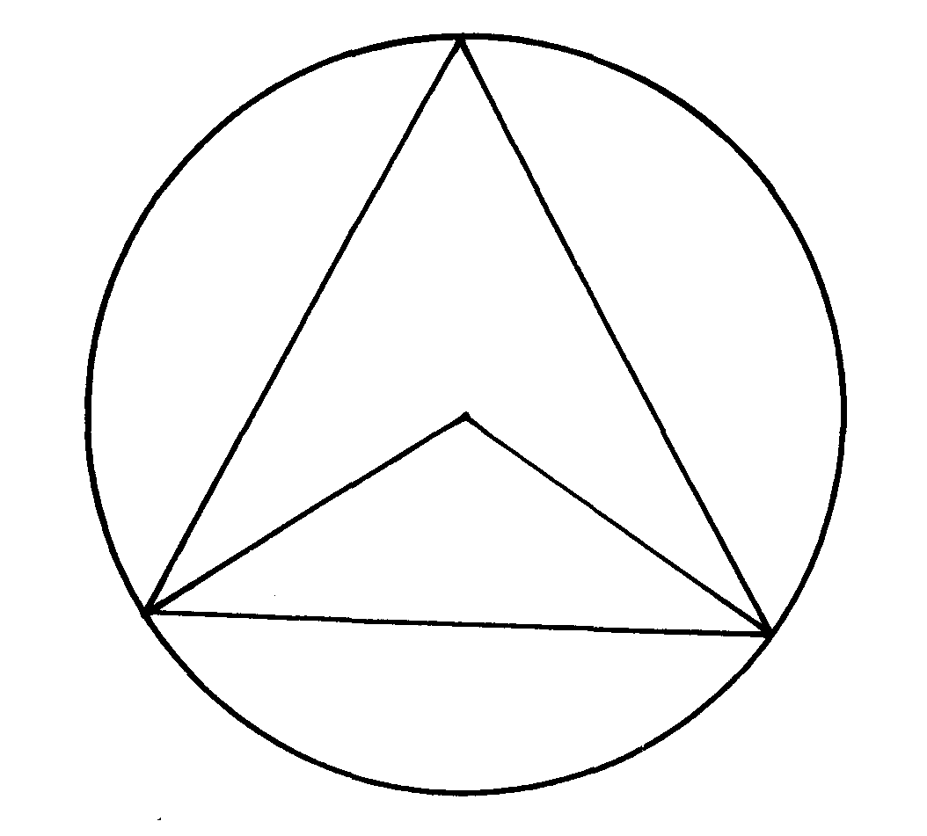
C
A
B
O
30º

Calculate the size of angle ACB. (3mks)

11. Calculate the perimeter of a rhombus whose diagonals are 12cm and 5 cm (4mks)

12. A metal hemisphere of radius 12cm is melted down and recast into the shape of a cone of
base radius 6cm. find the perpendicular height of the cone. ( 4mks)

13. The coordinates of the line AB are A ( 4,6) and B ( 12,10) . Find the equation of a perpendicular
line to line AB, passing through the mid-point of the line AB (3mks)

14. Two similar jugs have capacities 0.25 litres and 2 litres respectively. If the circumference of the smaller jug is 5.8cm calculate the circumference of the larger jug. (3mks)

15. Find the range of values of x which statisfy the inequality. 2x +1< 11< 6x – 1.
Illustrate your answer on the number line (4mks)

16. The figure below represents s a hexagonal prism, whose height is 20cm. the cross – section
of the prism is a regular hexagon of side 5 cm. Calculate the volume of the prism; give your
answer to 2dp (4mks)
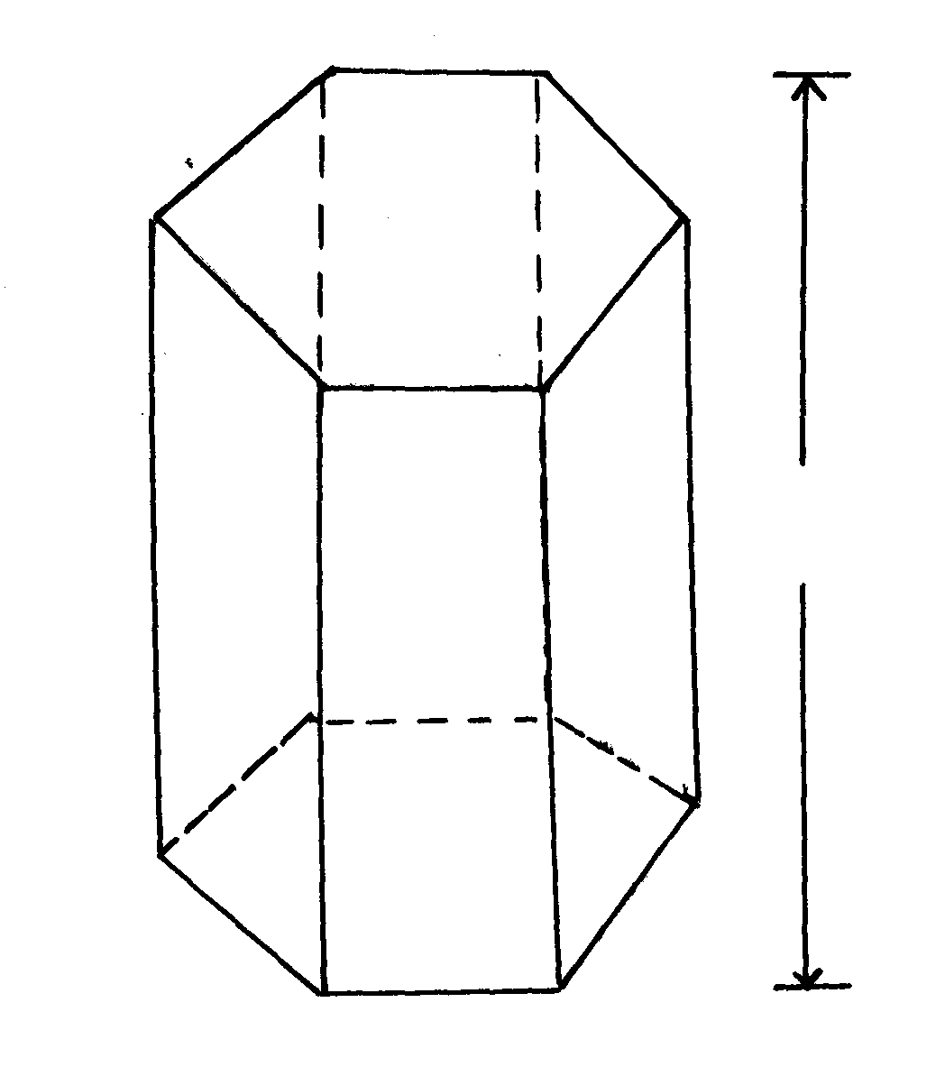
20cm
5cm

SECTION II ( 50 MARKS)
Answer only five questions in this section in the space provided.

17. The figure below shows part of a circle centre O, radius 6cm; the Length of the chord AB is 9 cm

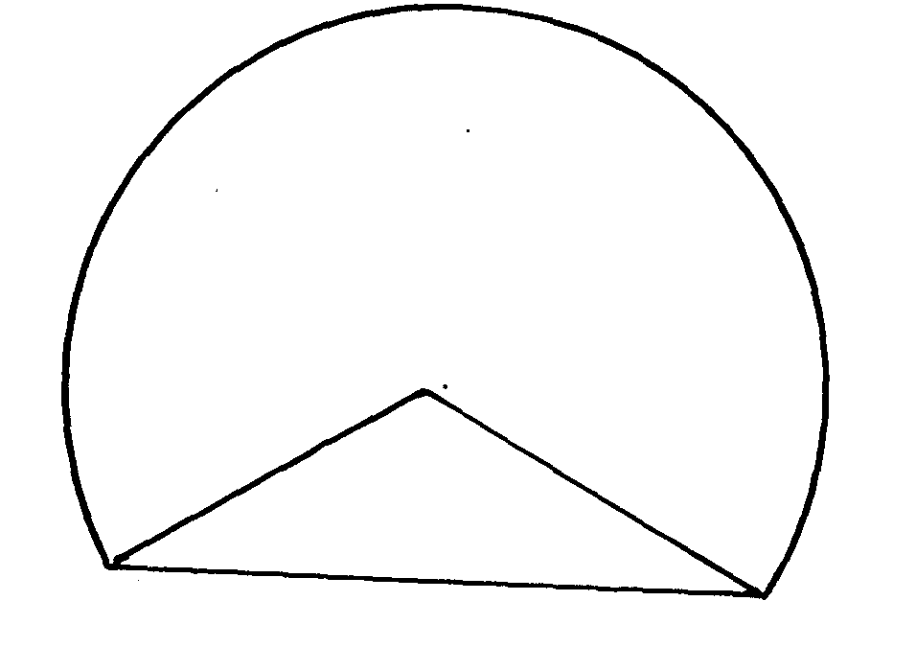
6cm
9cm
O
B
A

a) Calculate the area of the major segment (7mks)

b) Given that the sides of triangle are 7cm, 9cm and 11cm.Calculate the area of the triangle. (3mks)

18 a) By choosing any three suitable pairs of values of x and y complete the table of values for each function.
(i) x + 3y = 15 (2mks)
x
y
2
x
y
(ii) x – y = 4 (2mks)
3

b) Using the grid provided , and on the same axes, draw the lines x + 3y = 15 and x – y = 4 (4mks)
2 3

c) Use your graph to solve the equations x + 3y = 15 (2mks)
2
x – y = 4
3

19. The ratio of Kipto’s Salary to Mary’s is 5:3. Kipto’s salary rose by 12% to Kshs. 22400. Mary’s salary was also raised by x%. The total of their new salaries was Kshs. 36 200.
a) Calculate
(i) Kipto’s Salary before the increase (2mks)

(ii) Mary’s Salary before the increase. (2mks)

(b) Determine Mary’s salary after the increase. (1mk)

(c) What was the percentage increase in Mary’s Salary. (2mks)

(d) Determine the new ratio of their salaries. (2mks)

(e) Calculate the combined percentage increases for both of them. ( 1mk)

20. The mean mass of 5 boys is 54.4 kg. Three boys of masses 52kg, 55.1 kg and 57.5 kg join the five. Calculate the mean mass of the 8 boys (3mks)

b) The table below shows the distribution of ages of workers in certain organization.

Age (Years ) | Number of Workers
20 – 24  25 – 29  30 – 34  35 -39  40 - 44 | 5  10  18  15  12
i) State the modal class (1mk)

ii) Calculate the mean age (3mks)

iii) Calculate the median age (3mks)

21. a) A solid sphere of radius 8.4cm is dropped into a cylinder of radius 12cm and containing water upto a height of 10cm.
Determine the new height of water in the cylinder (6mks)

b) If the mass of the sphere is 100g; determine
(i) Density of the solid. (2mks)

(ii) Volume of similar solid which is irregular given that its mass is 800g; correct to the
nearest cm³. (2mks)

- If x + y = 3 and x² + y² = 29. Determine the values of
(i) x² + 2xy + y² (1mk)

(ii) 2xy (1mk)

(iii) x² – 2xy + y² (1mk)

(iv) x- y (2mks)

(b) Find the values of x and y (3mks)

(c) If x = -2 is a root of x² + kx + 8 = 0 , find the other root. (2mks)

- a) Two observers, A and B 500m a part observe a kite in the same vertical plane and from the
same side of it. The angles of elevation of the Kite are 30º and 20º respectively. Find how high,
the Kite was from the observers. (6mks)

Solve the equation cos x = sin 5x (2mks)

c) In the right angle triangle below. Find the length of AB in 2d.p (2mks)
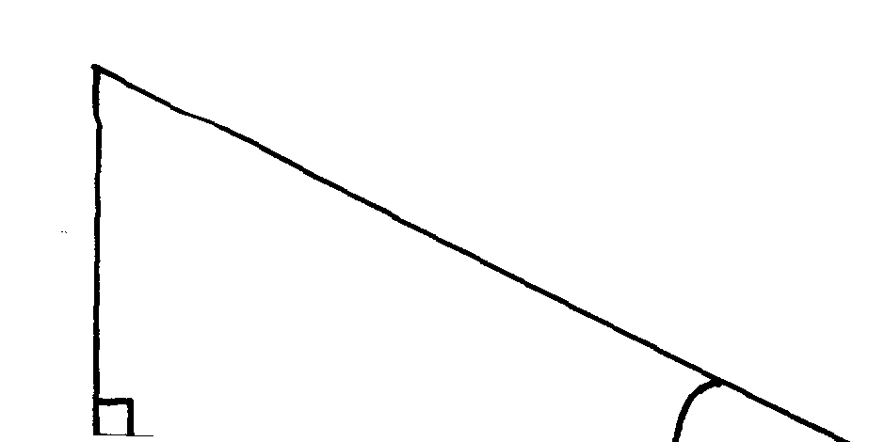
C

4 cm

35º
A
B
x

- A rectangle has a diagonal of 15.2cm. The diagonal makes an angle of 28º with the shorter
side of the rectangle
a) Calculate
(i) The Length and width of the rectangle. (4mks)

(ii) The are of the rectangle. (2mks)

(b) A triangular plot has two equal sides. The two equal sides meet at an angle of 40º. The area of the plot is 128.56m². Calculate the lengths of the sides of the plot. (4mks)

