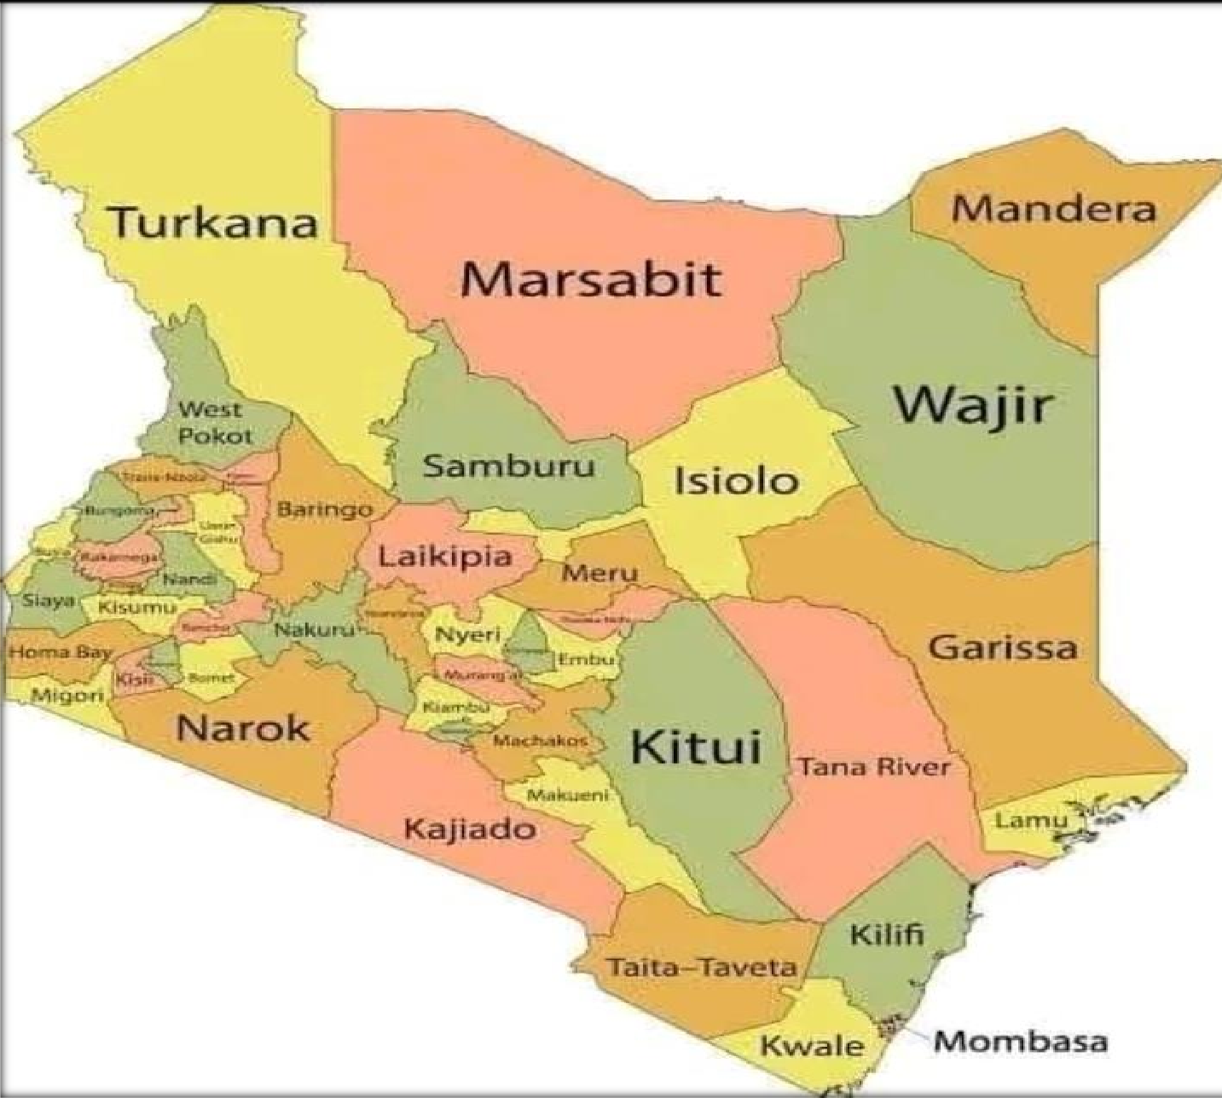








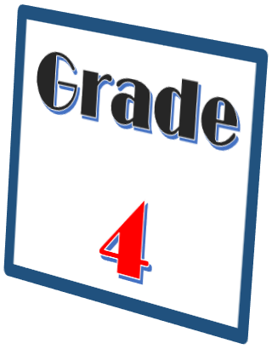

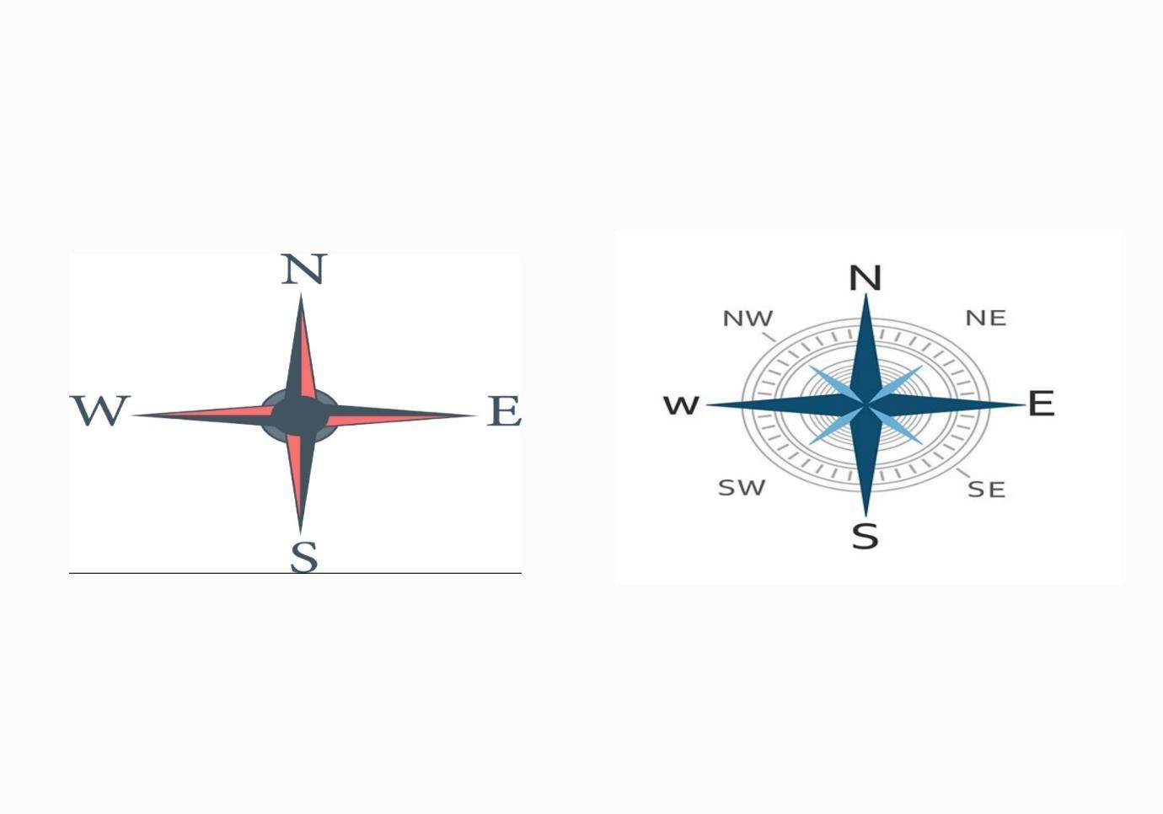

NATURAL AND BUILT ENVIRONMENT
Natural environment
Compass direction
A compass is an instrument used to give direction.
It has a needle that always point to the north.
A compass helps to establish the direction of one place from another. The four main points of a compass are known as cardinal points.
These points are: North, South, East and West. There are four other intermediate points.
They lie halfway between the cardinal points.

Map

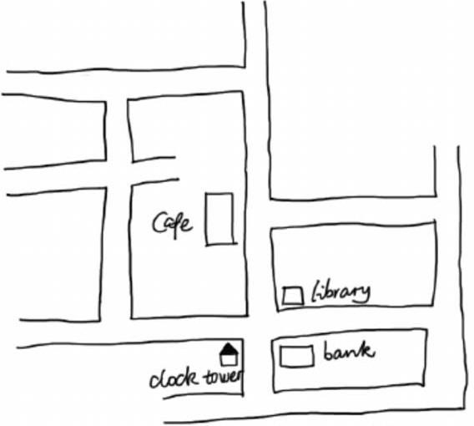
A map is a drawing that shows a part of the land and the things on the land.

Location and size of the county
Kenya is divided into parts called counties. Kenya has 47 counties.
A county is an area in the country that has its own government.

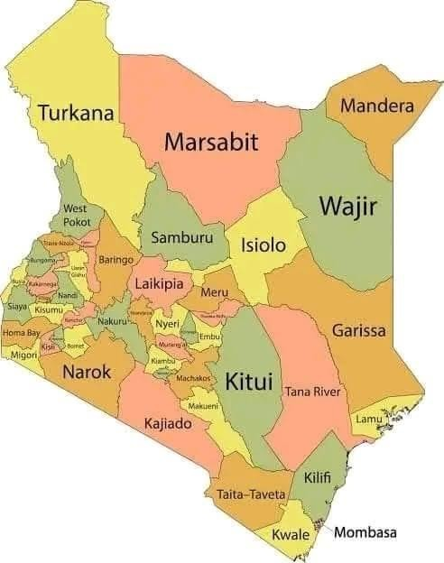
The largest county in Kenya is Turkana.
A county which has the capital city in Kenya is Nairobi. The smallest county in Kenya is Mombasa.
Our school is located in Kericho County.

Sub counties in Kericho County
A county is made up of small administrative parts called sub counties. Kericho County is made up of 6 sub counties namely;
- Belgut
- Ainamoi

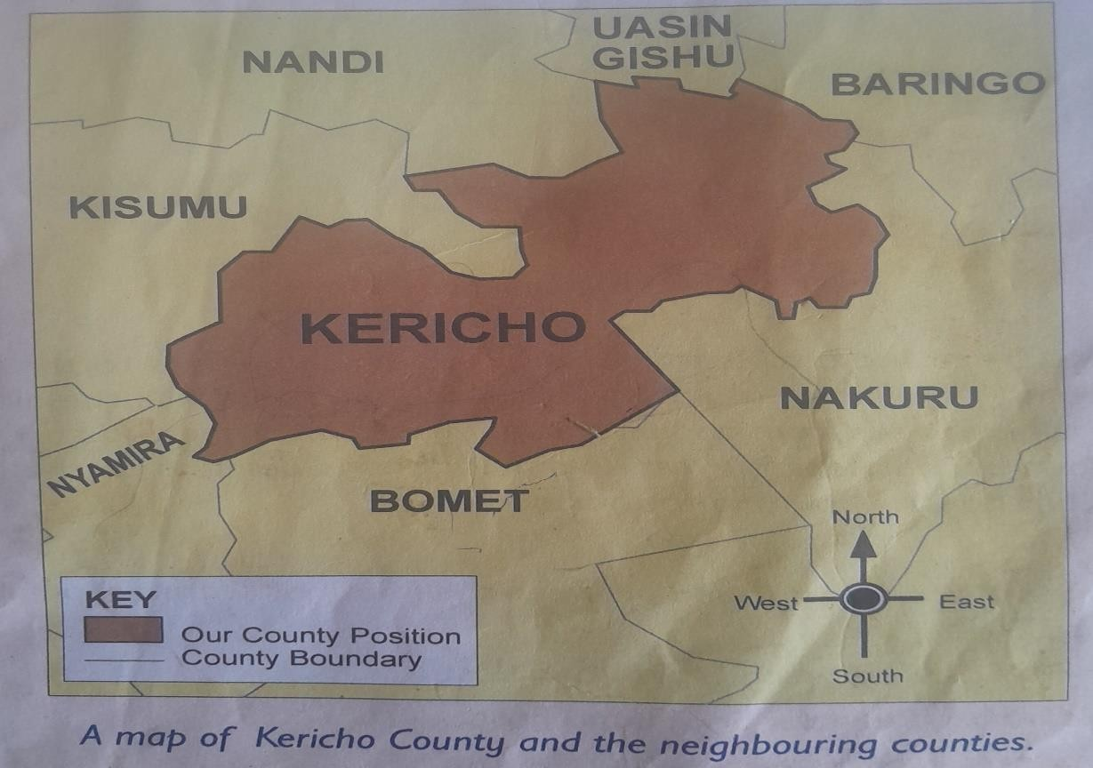
- Bureti
- Kipkelion West
- Kipkelion East
- Soin Sigowet

The neighbors of Kericho County

Every county in Kenya shares a boundary.
Counties that share a boundary with each other are said to be neighbors. A boundary is an imaginary line separates a place from another.
The neighbors of Kericho County are;

- Nandi county and Uasin Gishu to the north.
- Baringo county to the north east.
- Nakuru County to the east.
- Bomet County to the south.
- Nyamira County to the south west.
- Kisumu County to the west.

Major physical features in Kericho County

Physical features are natural things found on land around us.
Physical features include hills, plains, rivers, oceans, swamps, valley, mountains and lakes.

The following are major physical features in Kericho County;

1. Rivers
a) River Chemosit
b) River kimologit
c) River kipchorian
d) River kimugu
e) River itare
2. Swamps
a) Daraja sita
b) Complex
c) Nyagacho
3. Hills
a) Bureti hills
b) Mau hills
c) Binyiny hills
d) Kipsigis hills
e) Lemotit hill
f) Chilchila hills
4. Valleys
a) Chemosit valley
b) Ngendalel valley
c) Kipchorian valley

Importance of physical features

  - Hills and mountains are sources of rivers.
  - Some Hills and mountains are tourist attractions.
  - Hills are suitable sites for installation of communication equipment e.g masts.
  - Rivers, lakes, oceans and swamps provide water for domestic use.
  - Some rivers are used as boundary markers.
  - Plains are suitable farming areas.
  - Plains are good grazing areas for livestock.
  - Some plains are home to wildlife which attracts tourists.
  - Reeds growing in swamps are used for weaving and basketry
  - Some rivers and lakes are used to provide means for transport.

Ways of protecting physical features
Creating awareness on their importance.

Avoid dumping or disposing wastes into water sources.

Planting more trees (Afforestation)

Forest-fencing using electric fence.

Enforcing laws enforcing on waste disposal from factories.

Discourage farming along the River Bank.

Control erosion to curb silting and pollution.

Seasons in the county

Season-is a long period of time over which one type of weather is experienced. A season can be either hot, dry, cold or wet. March, April and May are wet months. January and February are dry months. Seasons affect our activities in the county.

Activities carried out during wet season

- Planting crops
- Weeding
- Fishing

Activities carried out during dry season

- Fishing
- Harvesting crops
- Collecting sand
- Repairing roofs
- Digging

Activities carried out during cold season

- Planting crops
- Fishing
- Weeding

Activities carried out during hot season

- Fishing
- Harvesting crops
- Collecting sand
- Digging
- Repairing roofs

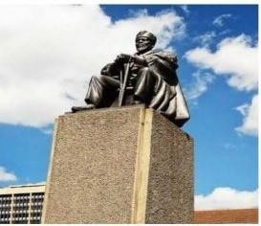
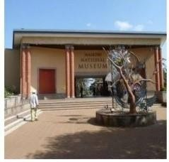
Work to do
- What is a season?
- Write down activities done during the rainy season.

- Which seasons are experienced in our county?

Built environments

A built environment refers to the environment made by human beings to enable them carry out various activities.

Historical built environment in the county
Historical built environment have way of life and beliefs about people. Kenya is blessed with numerous historic built environments.

They include; museums, monuments,cultural centres and old buildings.
Examples of Historical built environment in Nairobi County

Nairobi museum.

Jomo Kenyatta statue.

Bomas of Kenya.

What i should know

Museum is a place where works of art, culture and other important items kept.

Museum curator is a who is in charge of objects in a museum.

Monument is a structure that reminds people of important events or famous people.

Cultural centre is a place or building that promotes the culture of a community.

Importance of the historical built environment

Help us to learn our history and culture.

Promotes peace and unity as we are able to understand other cultures.

Source of revenue to our county.

It has created employment to many people.

Ways of taking care of historical built environment

Ensuring there's a good security in history buildings.

Keeping the monuments and cultural centre buildings clean.

Repairing cultural centre buildings.

PEOPLE AND POPULATION

Interdependence of people

Depend- to rely on somebody or something for a certain thing.

Interdependence- being dependent on each other for different things.

We need each other in different ways. We cannot get all the things we need. Interdependence makes work easier.
It also promotes unity among the people.

Importance of interdependence in the county

- It promotes love and unity.

- Work is done faster.

- The environment is taken care of.

- It leads to development of schools, roads and hospitals.

- Members of the community are able to get the things they need for their families.

Population distribution in the county

Population- refers to the total number of people living in an area.

Population distribution- is the way people are spread out over a given area of land. Population distribution can be dense, sparse or uneven. Areas with both sparse and dense populations are said to be uneven. Dry areas are sparsely populated. Many dots on a map means that the population distribution in that area is dense. Few dots on a map means population distribution in that area is sparse.

Factors that contribute to dense population

  - Fertile soils.
  - Water.
  - Good transport and communication.
  - Good climate.
  - Trading centres.

  - Flat lands

Factors that contribute to sparse population

Steep slopes.

Harsh climate.

Lack of water.

Pest and diseases

Large tracts of land being utilized for farming.

Some vegetation.

Patterns of population distribution

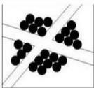
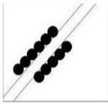
People settle on the land in different ways.
Population in an area can form different patterns.
The patterns of population distribution may be represented on a map using colour, shading as well as dots.
When people settle along a certain road, a river or railway-it is referred to as linear pattern.
When people settle around a water point, an industry or a town-the pattern is referred to as clustered or nucleated.
When people settle without any order.The houses are built anywherethe pattern is referred to as scattered.

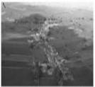
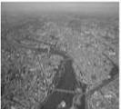

Linear Nucleated

Work to do

- What is population?
- An area that has many people living close together is populated.

- Draw an area that is:

  - Sparsely populated.

  - Densely populated.

CULTURE AND SOCIAL ORGANISATIONS

Culture-is the way of life of a community.

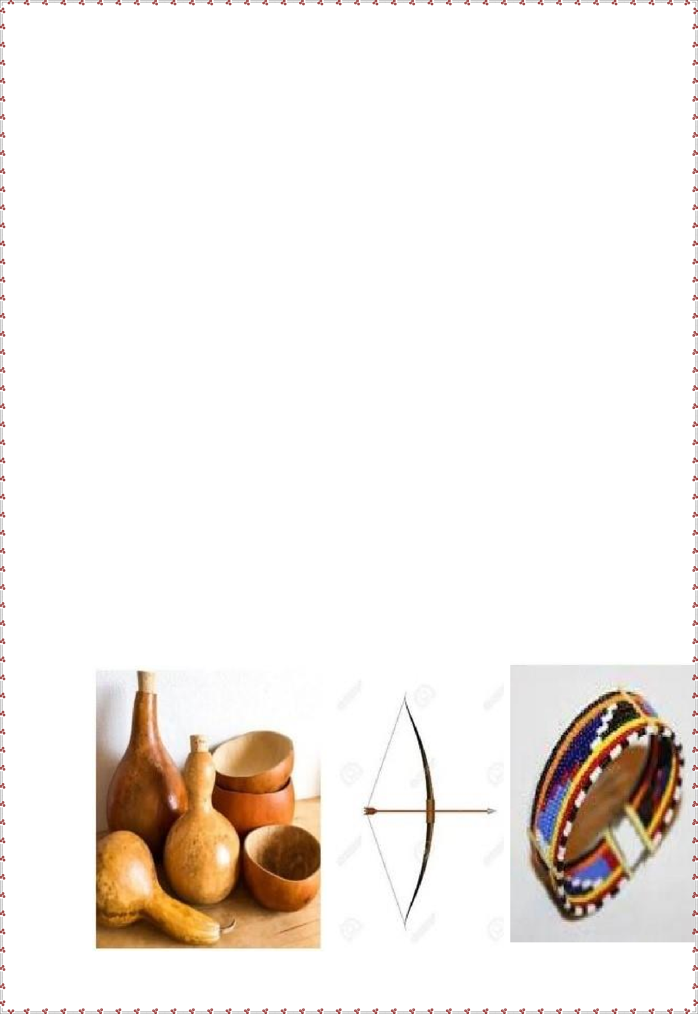
It is influenced by the customs, beliefs and traditions of a
community.

Aspects of culture
    - The food we eat.
    - The houses we live in.
    - Sports and games we take part in.
    - Festivals and ceremonies.
    - The artefacts they keep.

What I should know
Aspects of culture-are also referred or known as elements of culture.

Artefacts-are tools and items that were made and used by our ancestors.

Cultural artefacts are kept in a museum.

Examples of cultural
artefacts

Bows and arrows.

Drums and jingles.

Bangles, bracelets and earrings.

Gourds and calabashes. Spears and shields.


Work to do
- What is culture?

- Name the aspects of traditional culture in your county.

The School

A school is an institution where learners go to learn.

The history of the school

Every school has its own history.

Learners should get informed of how their school started.

Here are some of the things learners should know about their school:

The year in which their school was started.

- Who started the school?

- The reason why it was started.

- Who was the first head teacher?

- How many pupils were there when it got started?

How many teachers were there when it was started?

- Who is the current head teacher?

·How many learners are there now?

The school motto and values
School motto-a short statement about the aims and beliefs of a school.

Importance of a school motto

- A school motto guides the behaviour of learners.
- It helps learners to remember what they need to do to perform well in school.
- It encourage learners to develop some values such as patience,
determination and discipline.
- It also reminds learners to be good examples to others.

Where a school motto can be written

On the school signpost on the school gate.

On the school van or bus.

On the school badge.

On the pupils exercise books.

Examples of a school motto

Strong foundation is the key to success.

Pathway to excellence.

Hard work pays.

Education is the key to success.

Aspire for success.

Work to do

- Write down your school motto.

Core values in the school

These are the most important beliefs of a person or group.

Examples

Responsibility.

Love.
Determination.

The school routine

A school routine is a set of activities that have been planned to take place every day in the school.

Day schools and boarding schools have different routines.

Lower and upper primary have different routines.

A class timetable shows part of the school routine.

A school routine guide us in our activities at school.

Work to do

  - What is a school motto?

  - Write to places where a school motto can be written.

a)

b)

c)

  - The values of a school can be found in a school routine.

  - What is a school routine?

  - What is a school?

  - What are some of the core values in a school?
a)

b)

c)

d)

RESOURCES AND ECONOMIC ACTIVITIES

Resources are things that we use to make income or create wealth.

Water, soil, animals, forests and minerals are examples of resources.

People in the counties exploit resources to create wealth and satisfy their needs.

We should strive to conserve our resources so that the future generations can benefit from them.

Work to do

- Name water bodies found in your county.

- Name some forests found in our county.

- Animals kept at home are called

- Many trees growing together are called

- .Name three types of soils in your county.

Economic activities in the county

People do different activities to earn money.

Economic activities are the various ways we use resources to earn money.

The major aim of economic activities is to produce goods and make them available to consumers.

Main economic activitiesin our county
Agriculture Trade
Transport Communication Fishing
Industry Forestry tourism

Trade in the county
Trade is an economic activity that involves buying and selling of goods and services.

There are two methods of trades; Barter trade and currency trade.

Barter trader occurs when two people exchange goods and services without use of money.

Barter trade is not flexible.

Goods cannot be broken into smaller units.

Currency trade involves the use of money.

Money was introduced by Europeans.

Before introduction of coins and notes, Arabs used cowrie shells or beads as currency.
All counties have tradling centres or markets where trade takes place.

Importance of trade in the county

- Promotes peace and understanding.
- It enables people to get jobs.
- It leads to interaction of people in the county.
- It leads to the growth and expansion of towns.
- It enables people to get goods and services they need.
- It enables the county to collect taxes (revenue).

Taxes is the money paid to the government to enable it provide services to the people.

Work to do

  - What is trade?

  - The exchange of goods for other goods is known as

  - The use of money to pay for goods and services is known as trade.
  - Which people introduced coins and notes?

  - Write down three ways on how trade is important in your county.

Industries in the county

Industry is an activity where raw materials are made into useful products.

There are modern industries and traditional industries.

In traditional industries, production is on small scale.

Most of the work is done by people as opposed to machines.

Traditional industries have been around for a long time.

Modern industries produce goods on a large scale.

Examples of Traditional industries

Weaving and basketry

Leather work

Pottery

Ironworking

Woodwork and carving

Boat making

Granary making

Gourd making
and beading.
Examples of
modern
industries

Cement manufacturing

Petroleum refining
Tea processing

Milk processing

Paper making

Steel making

Baking

Computer assembly

Benefits of industries in the county

People are able to get goods that they need. Industries provide jobs for the people in the county.
Industries brings development to the county.

The county government earns money from industries.

Transport

This is the movement of people and goods from one place to another.

Transport takes place in all counties

Forms of transport

Roads Railways

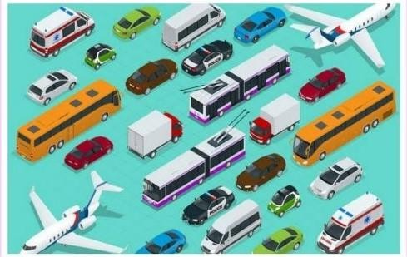
Air Water

Means of Transport

Buses Cars
Lorries Trains Aeroplanes Ship
Boats

Communication

This is the sending of messages or information from one person to another.

Examples of means of communication

Radio. Newspapers.
Mobile phones. Television.
Letters.

Mining

This is the activity of removing/extracting minerals from the ground.

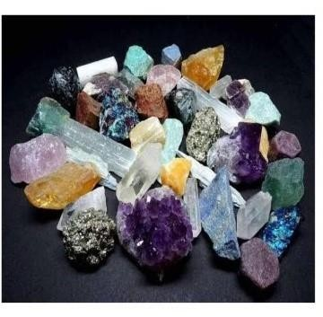

Examples of minerals
- Iron
- Salt
- Gold
- Gemstones
- Sand
- Oil
- Coal

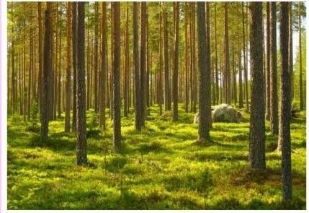

Forestry
This is the planting of trees and taking care of them. It is also taking care of trees that grows on their own.
Many counties have forest.

Examples of forests in Nairobi County

Karura forests

Ngong forest

Tourism
This the practice of travelling from one’s home area to other places to see interesting things.

Enterprise project in School

Project-is any work that is planned and done in an organised way to produce something new or to improve something.

Enterprise-A big project that brings money or income.

Projects we can start in school to earn money
Growing of kales.

Rearing of rabbits.
Poultry farming.
Making necklaces and bangles from seeds and beads.

Growing of onions.
Making flower vases from used plastic containers.

Planning for projects
Sharing roles and duties.
Writing down rules for the project to ensure safety.
Deciding on the things that need to be available for the project. (Budget)

Deciding on how to market the project.
Getting out permission from the head teacher/school director to carry out
the project.

Carrying the project
Making the

items e.g. necklaces, bangles etc. Marketing
the items.

Selling the items.
Checking on the success of the project.

Work to do
- What is a resource?
- Name three resources in our county?
- Protecting and taking care of resources is called?

- What is an enterprise project?
- Name five enterprise projects we can carry out in school.
- What is an industry?
- Name three industries in our county.
- Name two types of trade.
- Write five benefits of trade.
- What is an economic activity?

POLITICAL SYSTEMS AND CHANGE

Community leadership

Community leaders are people who are recognised in the community as having a special abilities, talents.

They represent the community's interests and plays a role of protecting them. This role could be paid for or voluntarily.
These leaders are normally consulted before important decisions in the community are made.

Leaders in the community

Council of elders.
Political leaders’ e.g. governors, senators, MPs etc.
Institution leaders’ e.g. head teachers, managers, prefects. Cultural leaders.
Religious leaders. E.g. pastors, I mams etc.

Duties/Roles/Functions of Community leaders
They lead people in prayers and worship.
They teach people good values in society.

They solve problems in the community.
They lead people in cultural events in the community.
They guide people to know what is right and wrong.

They ensure the culture and traditions of the community are not forgotten.

Qualities of a good leader
He/she should be a role model.(Lead by example) Willing to serve.
Honest and have integrity. Does not give or accept bribes. Must have self-control.
Must be mature and full of wisdom. Must be gentle and peaceful.
A good leader is fair.
Obeys the laws and leaders in authority. Must be orderly.
Work to do

  - Who is a community leader?
  - Name two examples of political leaders
  - Write down four qualities of a good leader.
  - List three duties of a community leader.
  - Name three institution leaders in our county.

CITIZENSHIP

Good citizenship in school

Citizen- is a person who belongs to a particular country.
Citizenship- the state of belonging to a country and enjoying the rights that the citizens of that country enjoy.
A good citizen in school respect their and other people property.
Good citizenship in school results in good relationships between learners and teachers. We should practise good citizenship to ensure peace and prosperity.

Qualities of a good citizen in school

Obedience, Hardworking, Honest, Taking care of our environment by planting trees and cleaning. Loving our school and teachers, Law abiding, taking care of less fortunate, Generous, Should be responsible and tolerant.

Cultural practices
These are actions of a community that are guided by certain beliefs and attitudes. Some cultural practices may hurt children and deny them their rights.

Examples of cultural practices that violate rights of children.
- Female genital mutilation.
- Early marriages.
- Force marriage.
- Child labour.
- Nutritional taboos.
- Traditional birth practices e.g preference of certain gender.

How children are abused in the community

- Excessive beating/canning without consideration.
- Using abusive language to them.
- Forcing young girls to get married.
- Mistreating children with special needs.
- Child trafficking/Stealing children.
- Body injuries.
- Poor health.
- Absenteeism from school.
- Tiredness and fatigue.
- Low self-esteem.
- It leads to poor performance.

How we can prevent children from abuse

- Speaking against the vice.
- Reporting the cases to relevant authority.
- Creating awareness to the public about child abuse.
- Establishing rehabilitation centres.
- Introducing strict laws against child abuse.

Ways we can protect ourselves from abuse

Child rights
- Stay in touch with friends and neighbours.
- Walk to and from school in groups.
- Scream loudly when you are in danger.
- Avoid using lonely roads.
- Keep important telephone numbers e.g those of parents and police to call when in trouble.
- Talk about cases of abuse to those people that you trust.

These are entitlement that children are supposed to be given They include;

Right to food. Right to shelter.

Work to do

  - Name three cultural practices that are harmful to children.
  - Write down three ways in which children are abused.
  - Name five effects of child abuse.
  - Name three ways that can be used to protect children from abuse.

Peace

Peace is a state of calmness without quarrels or fights.
It is referred as the state of being in harmony with others.

What promotes peace in school?

- Respecting each other.
- Obeying school rules and teachers instructions.
- Being punctual in school.
- Finishing teacher’s assignments.
- Treating each other fairly.
- Doing duties given to you.
- Helping those in need like persons with disabilities.
N/B: Things that promote peace are also known as factors that promote peace.

Peace education project
Identifying a peace education project that can be undertaken in school.
Initiating the peace project at school.
Planning a peace project at school.
Sharing responsibilities for peace project at school.
Evaluating success of peace project at school. The good things.

Peace project ideas
Peace education clubs.
Peace garden
Host conflict-resolution workshops.
Conduct entertainment

programmes including skits and plays. sports
tournaments.

Make posters for community sensitisation.

Work to do

  - What is peace?
  - Identify four factors that can promote peace in school.

  - How can we live in peace with others in the school?
  - Give two benefits of living in peace in school.

GOVERNANCE IN KENYA

Democracy in school

Democracy is a situation when people are given freedom to make discuss and share ideas freely.
Learners are treated fairly and are allowed to take part in making decisions on issues affecting them.
It brings about feelings of satisfaction and justice among learners.

Importance of democracy in school
Learners are able to express their ideas without fear.
It promotes peace and harmony in the school.
Promotes understanding between pupils and teachers.
Democracy in school helps us to choose leaders of our own choice.
Promotes equality and respect In school
Enables children to speak out their problems.

Children's government in school

The children government is a representative body in schools. It is made up of the following;
    - President·
    - Deputy president.
    - Representative of all classes·
    - Games prefects or leaders.
    - Environmental/Sanitation prefects.
    - Club representatives.

Members of children's government serve as voice of all learners in school.
It encourages learners to talk freely about ideas and issues affecting them.

Functions of the children's government in school
Help in coordinating activities in the school.
Report any problem to the teachers from the pupils.

duties.
Maintaining order in the school.
Maintaining cleanliness in the school by assigning pupils to perform d ifferent

Promotes music and drama in school through the prefect clubs. Promoting environmental conservation through the environmental and sanitation prefects.

Ways of supporting children's government

_ By listening to them.

By helping them.
By following school rules to avoid conflict.

Work to do

- What is children's government?
- Write down three leaders in children’s government.
- Write down three benefits of democracy in your school.
- Give the meaning of democracy.
- How do you support children's government in school?

The county government in Kenya

The republic of Kenya has two levels of governments;

National government.
  - County government
The county government is headed by the county governor.
The governor is elected by people together with deputy governor.
The county government is made up of;
The county assembly.
· The county executive.
There are 47 counties in Kenya.

The county assembly
Consist/comprises the following;

Members elected by

people from each ward. (MCAs)
Members representing

special groups.

Special seat members nominated by political parties.
The county assembly speakers.

NB: The main duty/work/function of the county assembly is to make county laws.

The county executive
Made up of;

The governor (head of county government) Deputy Governor:
Members of the county executive committee appointed by the
governor:
Other officials appointed by the governor:

NB: The main work/role of the county executive committee is implementing policies are carrying out executive functions in the county.

Duties of the county governor
Ensuring peace and order in the county.

Appointing members of the county executive committee and other county
officials.
Ensuring county government officers perform their duties well.
Receiving important visitors to the county.
Acting as a link between national government and county government Preparing reports for the county assembly on matters relating to the county.

Ensuring development projects are undertaken in the county.
Ensuring all laws are followed in the county. Guiding the county executive committee in preparing some laws in the county.

Services provided by the county government

Clean water and sanitation.
Maintaining county roads.
Health
Controlling plant and animal diseases.
Waste management
Education

Ways in which county

government get money

(Sources of revenue)

Grants (money) from national government. This is the main source.
Money from land rates.
Parking fees.
Rents from county houses.
Taxes called cess.(A form of tax charged by a county government for transportation of some goods into or within the county)

Sales of business permits and licences. Loans/Borrowing but with approval from the national government.

Work to do

- Who is the head of the county executive committee?
- Name three duties of a county governor in our county.
- State four ways through which the county government obtains or gets money.
- Who represent a ward to the county assembly?
- The county government is made up of the and the

- Name two other officers who make up the county government.
- Who is the head of the county government?

