Living and non-living things in the environment
- Things that have life are called living things.
Examples of living things are plants and animals such as human beings, cats, dogs, lions, butterflies, and others.
- Things that do not have life are called non-living things.
Examples of non-living things are books, buildings, table, soil, water and air.
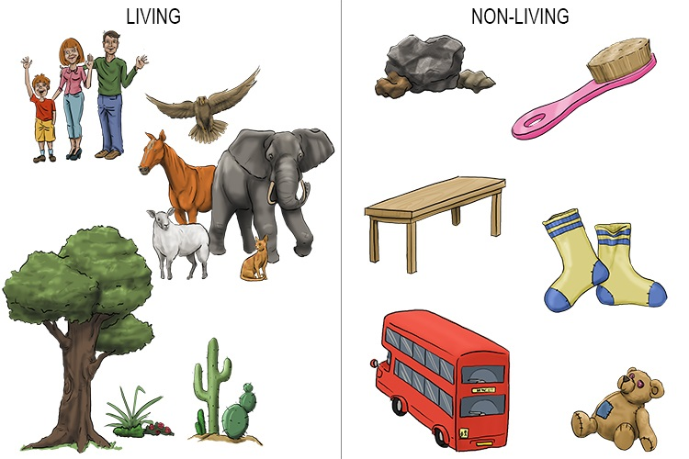

Characteristics of plants
The following are some characteristics of plants.
- Plants grow.
- Plants respond to changes in the environment.
- Plants die.
- Plants feed.
- Plants reproduce.

Characteristics of animals
- Animals grow.
- Animals respond to changes in the environment.
- They die.
- They feed.
- They reproduce.
- They move.
- They remove waste.

Vertebrates and Invertebrates
Vertebrates are animals with backbone.
Invertebrates are animals without backbone.

Examples of Vertebrates
- Goat
- Human
- Hen
- Fish
- Frog
- Sheep

Examples of Invertebrates
- Spider
- Butterfly
- Fly

Human Digestive System - Human Body

Human Digestive System Diagram
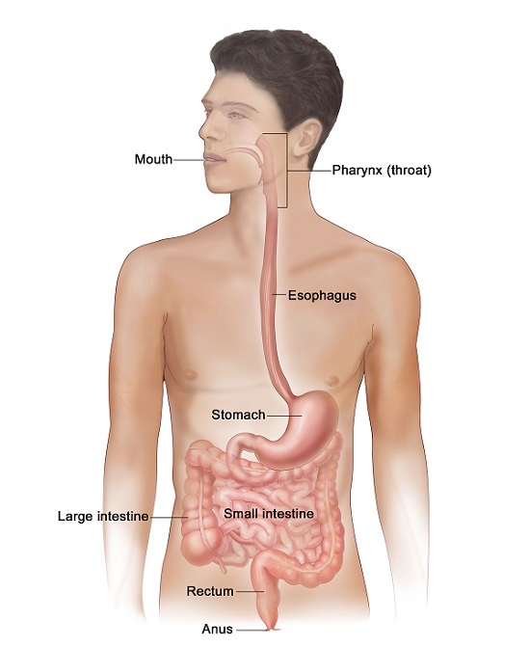

Functions of parts of digestive system

(i) Functions of the Mouth
- Food is chewed using teeth.
- Food mixes with saliva.

(ii) Functions of the Oesophagus
- This is the passage of food from the mouth to the stomach.
- It is also called gullet or food pipe.

(iii) Functions of the Stomach
- This is a food storage.
- Food mixes with digestive juice.

(iv) Functions of Small Intestine
- This is a place where food mixes with digestive juice.
- Digested food is absorbed into the body in the small intestine.

(v) Functions of Large Intestine
- Water and mineral salts are absorbed in the large intestine.
- There is no digestion in the large intestine.

(vi) Functions of the Rectum
- This is where undigested food is stored.

(vii) Functions of the Anus
- This is the passage of undigested food from the body.

The Environment: Introduction to Pollution
- Pollution is the introduction of pollutants into the environment.
- The parts of environment that are polluted are: air, water andsoil.

Air Pollution
- Air pollution is the introduction of harmful gases into air.
- Some of air pollutants in the environment are:
1. Bad smell
2. Dust
3. Smoke
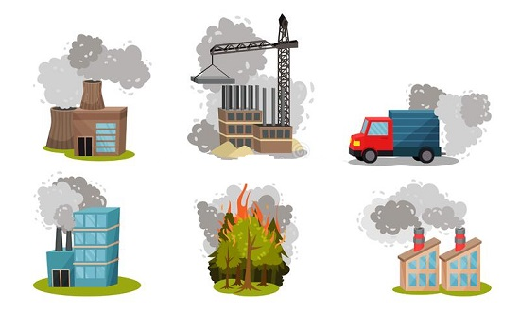

Effects of air Pollution on living things
- Breathing problems
- Irritation of the eyes
- Visibility
- Poor growth on plants

Ways of reducing air Pollution
(i) Proper disposal of waste at home.
(ii) Use of ventilation on improved latrines.
(iii) Sprinkling ash on pit latrines.
(iv) Sprinkling water on dusty roads.

Water Pollution
- Polluted water has harmful substances that affect living things.
- The harmful substances in the environment are called pollutants.
- The difference between clean and polluted water.
- Clean water has no harmful substances.
- Polluted water has harmful substances.

Water Pollutants
Some water pollutants are:
- Soil or mud
- Solid wastes
Solid wastes are plastics, papers, polythene, bottles and pieces of clothes.

Effects of Water Pollution
(i) Waterborne diseases cause vomiting and diarrhoea to human beings when they drink contaminated water.
(ii) Water pollution causes death of plants and animals.
(iii) Plants and animals cannot survive in areas with polluted water.

Ways of reducing water pollution
(i) Proper disposal of solid waste. Solid wastes include: kitchen waste, plastic and papers.
(ii) Proper disposal of dirty water in our homes.
(iii) Avoid taking bath, washing clothes or swimming in sources of water.
(iv) Fetching water for animals instead of watering them directly in rivers.

Note
Filtered water is NOT safe for drinking.
Filtered water SHOULD BE boiled before drinking.

States of Matter: Understanding Matter
- Matter is anything that occupies space and has mass.

States of Matter
There are three states of matter:
- Solids
- Liquids
- Gases

Solids

Characteristics of Solids
- Solids have definite shape. One can tell the shape of solid. The shape can be regular or irregular.
- Solids have definite volume or size. The volume of solid can be measured.
- Solids have definite mass. Some solids are heavy while others are lighter.

Examples of Solids
- Sugar
- Rock
- Wood
- Glass
- Table
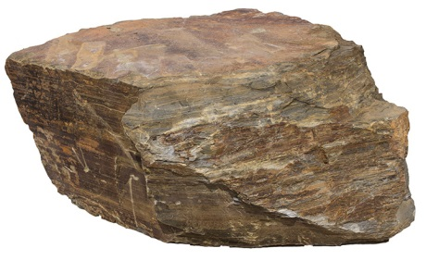

Liquids

Characteristics of Liquids
- Liquids do not have definite shape. They take the shape of the container.
- Liquids have definite volume.
- Liquids have definite mass. They may be lighter or heavier when two are compared.

Examples of Liquids
- Water
- Milk
- Blood
- Urine
- Bromine
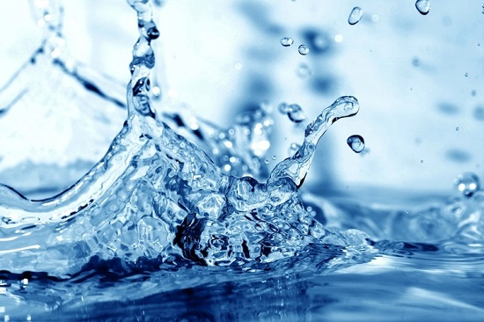

Gases

Characteristics of Gases
- Gases have no definite shape.
- Gases have no definite volume.
- Gases have definite mass that's why an inflated balloon lifts a deflated balloon when placed on a beam balance.

Examples of Gases
- Carbon dioxide
- Ozone
- Nitrogen
- Hydrogen
- Freon

Floating and Sinking
- Things that remain on the surface of water are called floaters.
- Things that move to the bottom of the surface are called sinkers.

Factors that Affect Sinking and Floating
(i) Type of material: Objects float or sink depending on the type of material they are made of. Some materials are floaters while others are sinkers.
(ii) Shape of the object: Shape of the objects affect sinking and floating.
Sinkers can be made to float by changing their shape.
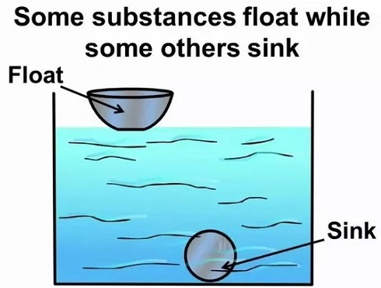

Force and its Effects: Introduction
- Force is a push or a pull.
- Force make objects move.
- When an object is pushed, pulled or lifted it moves.
- Force affects the following:
- Movement of object
- Shape of object
- Direction of object

Effects of force on movement
- Applying a kick (push) on a ball will make it move.
- Applying a push on a ball on the opposite direction stops the moving ball.
- Force can make an object that is stationary to start moving.
- Force can make a moving object to stop moving.

Effects of force on shape of objects
- Force changes shape of an object.

Effects of force on moving object
- Force changes the direction of a moving object.

Sound Energy
- Sound travels in all directions.

Light Energy
- Materials that allow light to pass through and one can see through are called transparent materials.
- Materials that allow some light to pass through but one cannot see through are called translucent materials.
- Materials that do not allow any light to pass through are called opaque materials.

Heat Energy

Conduction of Heat
- Heat moves from one end of the metal rod to the other through conduction.
- Conduction is the transfer of heat in solids.

Good and Poor Conductors of Heat
- Materials that allow heat to pass through are called good conductors.
- Materials that do not allow heat to pass through are called poor conductors.
- Cooking utensils are made of good conductors of heat to allow heat to pass through for easy cooking.
- Handles of cooking utensils are made of poor conductors of heat to prevent accident through burning.

Machines

Levers
- A lever is a simple machine used to make work easier.
- There are many types of levers we use in our day to day life.
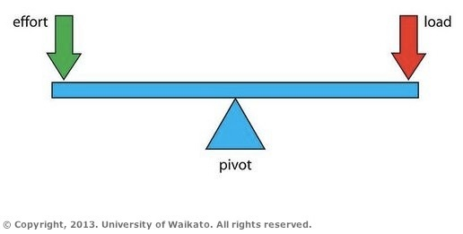

Parts of Levers
- The turning points is called fulcrum.
- The force applied to do work is called effort.
- The work being done is called load.

Weather and the Sky: The Clouds
Last Updated: 03-02-2023

Introduction to the Clouds
- Clouds have different shapes and colours.
- The types of clouds in the sky are:
- Cumulus clouds.
- Nimbus clouds.
- Cirrus clouds.
- Stratus clouds

Nimbus Clouds

Characteristics of Nimbus Clouds
- They are dark grey in colour.
- They appear low in the sky.
- They cover large part of the sky and are grey in colour.
- They indicate heavy rainfall which is accompanied by lightning and thunderstorms.

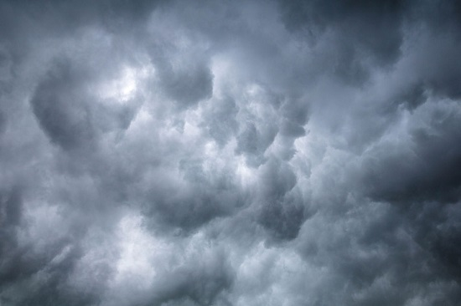

Cirrus Clouds

Characteristics of Cirrus Clouds
- They appear whitish.
- They look like balls of cotton wool.
- They are high in the sky.
- They produce little rain.
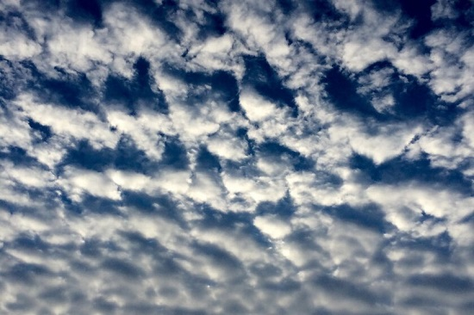

Stratus Clouds

Characteristics of Stratus Clouds
- They look like white sheet covering the sky
- The sheets are arranged in the sky.
- They appear low sometimes hanging like mountains

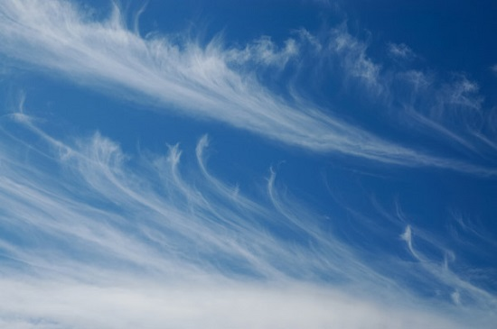

Other bodies Observed in the Sky at Night
- Moon
- Stars
- Satellites

