**MARKING SCHEME**

**END TERM 1 2025**

**GEOGRAPHY EXAM FORM TWO**

Answer all questions

1a. Define the term environment (2 mks)

All external conditions surrounding an organism which has influence over its behaviour

2 using a well labelled diagram, describe the formation of relief rainfall 7mks

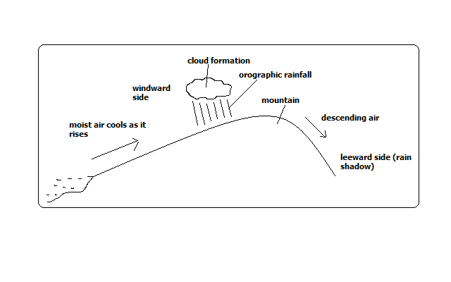

Moist air is forced to rise over a hill or mountain.

The temperature and air pressure decreases making it to expand.

Air cools due to decreased temperature and decreased pressure causing it to expand.

Moisture condenses forming tiny water droplets (clouds).

The tiny water droplets in clouds merge and become too heavy to be suspended in air and fall as rain.

Air proceeds to the leeward side with low moisture content.

Since its heavier due to being cool it descends over that side and gets warmed making it to hold onto the little moisture it had causing that side to receive low rainfall (rain shadow).

3a..Define fieldwork 2mks

Scientific study of geography using the environment as a laboratory or source of information.

b.identify any 5 importance of fieldwork 5mks

Reinforces what has been learnt in class.

Enables one to gain more geographical knowledge.

It breaks the monotony of classroom work.

It provides learner with practical skills of collecting, recording and analysing data and report writing.

Gives students an opportunity to go out and practise what they have learnt in class.

Enables students to familiarise themselves with the environment and develop a positive attitude towards it.

Enables students to develop a positive attitude towards manual work.

Promotes development of virtues like cooperation by working in groups.

4.a,give 6 characteristics of minerals 6mks

Different degrees of hardness e.g. some are very hard e.g. diamond while others are very soft e.g. talc.

Some have atoms arranged in an orderly manner to form crystals e.g. quartz form a 6- sided prism.

Varying number of elements e.g. gold has one (Av) while quartz has 2 (SiO2).

Different abilities to allow light to pass through e.g. some are transparent, opaque or translucent.

Specific colours e.g. gold is shiny yellow while copper is brown.

Have specific surface appearance (lustre) when they reflect light i.e. metallic (shiny) or non-metallic (glass like).

Definite chemical composition or constant ratio of elements e.g. quartz has one atom of silicon and two atoms of oxygen

Tendency to break along certain lines or cleavage) e.g. flint has cleavage like that of glass.

b. Give 6 significance of minerals to the economy of the country 6mks

Kenya earns foreign exchange from exportation of minerals which is used to import goods and services and fund development projects.

Mining is a source of employment to people such as those who work in mines, in cement factories, in transport secMining has led to development of industries by providing raw materials used in those industries e.g. limestone used in cement factories, coal used in iron and steel industries, soda ash used in glass industry, etc.

Mining has led to development of transport system to make mining areas accessible e.g. Magadi soda mine is connected to the main Mombasa-Nairobi railway line.

Mining has led to development of settlements e.g. Magadi town which originated from the mining of soda ash.

Mining is a source of market for goods and services e.g. there are shops and markets, banking and insurance services offered to people working in mines and related industries.

5a..what is earth movement 2mks

these are displacements of rocks of the crust caused by tectonic forces

b.State 4 causes of earth movement 4mks

Gravitative pressure

Magma movement

Isostatic adjustments

Movement of convectional currents

6.a Describe continental drift theory 6mks

The theory was initiated by a German called Alfred Wegner to explain the theory of the present continent it stipulates as follows:

The earth was initially a large land mass called Pangea. It was surrounded by a great sea called panthelasa.

Later Pangea broke up into blocks namely Laurasia and Gondwana land.The blocks separated by a narrow sea called Tethys.

Eventually, Laurasia broke and formed the Northern continent e.g. Europe and America while Gondwana land Australia and Africa

b.Identify any 4 reasons why we should study the theory of plate tectonic 4mks

It explains the current positioning of crustal rocks by compressional forces.

It enables as ton understand the creation of structural land forms e.g. fold mountains

It explains the destruction of structural land forces

It helps us understand how the earth maintains its boundary

It explains the cause of the earthquakes and volcanicity

7 a.Outline 4 fold mountain building periods 4mks

Caledonian

Chanian

Alpine

hercynian

.b.Identify 6 significance of folding 6mks

Folding mountains attract tourists hence earning foreign exchange, which is used to develop other sectors of the economy.

Synclines between fold mountains provide route ways for transport in rugged landscape hence transportation

High rainfall on fold mountains slope provide moisture which forestry provides timber for building and construction#

High rainfall received on the windward side of Fold Mountains attracts dense settlement and farming.

The process of folding leads to dynamic rock metamorphism of rocks leading to the formation of minerals hence mining.

Steep and rugged relief due to folding discourages construction of roads and other routes for transport.

The synclines have good fertile soils that support farming

8. a Identify any 3 intrusive lanforms formed by vulcanicity 3mks

Sill

Dyke

Laccolityth

Batholith

Phacolith

b. Give 4 effects of earthquakes 4mks

Loss of life and destruction of properties e.g. Roads, electricity lines and buildings. Earthquakes in a built up area may destroy buildings

Earthquakes in sea beds give waves which give rise to tsunamis e.g. Japan and pacific oceans in general. The waves may cause flooding along the coast.

Earthquakes trigger occurrence of fire which may burn properties and vegetation

The shaking of the crust triggers landslide which may cause loss of life

Earthquakes result into permanent displacement of the earth surface

They can lower or raise the floor e.g. Sea floor and coastal regions in Alaska and sudden submergence of the land near the sea causing flood

They restrict the development of towns

After shocking which are small/minor trembling that follows major earthquakes, ends to further weaken already weakened structure by earthquakes

May lead to sinking of part of the earth’s crust

May lead to the uplifting of the part of the earth’s crust

May lead to submergence of the crustal rocks

Earthquakes cause fractures on the road which hinder transport and communication

9.Highligh methods of representing relief on topographical maps 3mks

Contours

Formlines

Hachures

Pictorial method

Hill shading

Spot height

Cliff and rock drawing

Colouring

10.a. what is a photograph 2mks

Is an image of an object recorded by a camera on a film

b. give two types of photographs 2mks

aerial photograph

Ground photograph

c.Give the parts of a photography 2mks

fore ground

background

middle ground