Name: …………………………………………………………… Admn. No. ……………………………
School: …………………………………………………………. Candidate’s Sign. …………..............
Date: ………………………………............................................

233
CHEMISTRY
TIME: 2 HOURS

TERM 2 MID TERM 2 ASSESMENT EXAMINATION -2022
FORM 2
CHEMISTRY

INSTRUCTIONS TO THE CANDIDATES:-

- Answer all the questions in the spaces provided.
- Write your name and admission number, school, date in the spaces provided.
- Mathematical tables and electronic calculators may be used for calculation.
- All workings must be clearly shown where necessary

For examiner’s use only:

Question | Maximum score | Candidate’s score
1-21 | 80

This paper consists of 11 printed pages. Candidates should check to ascertain that all pages are printed as indicated and that questions are missing.

1. Study the set-up below and answer the questions hat follow;
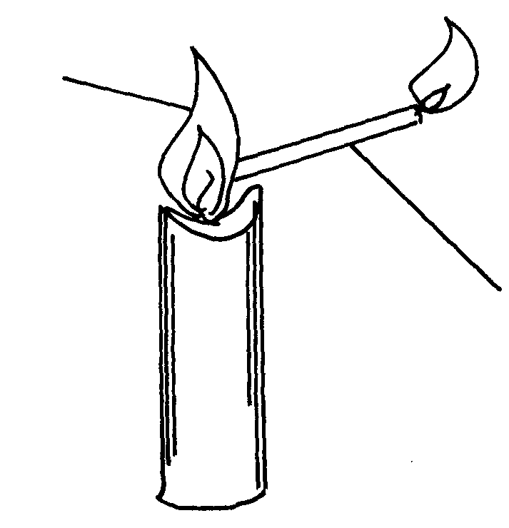
Bunsen burner flame
Flame

Delivery tube

(a) What does the experiment demonstrate? (1mk)
…………………………………………………………………………………………………..
(b) When is this type of Bunsen burner flame produced? (1mk)
…………………………………………………………………………………………………..
(c) Give two characteristics of the type of flame used in the set-up (2mks)
…………………………………………………………………………………………………..
…………………………………………………………………………………………………..
2. (a) State the role of the following parts during fractional distillation of a mixture of water
and ethanol.
(i) fractionating column (1mk)
…………………………………………………………………………………………………..
(ii) Glass beads in the fractionating column (1mk)
…………………………………………………………………………………………………..
(b) State any two applications of fractional distillation process. (2mks)
…………………………………………………………………………………………………..
…………………………………………………………………………………………………..
3. A certain indicator was added to a solution. The pH value on the scale that was used with this indicator was read as 6.5
(a) Name the indicator (1mk)
…………………………………………………………………………………………………..
(b) State the nature of the solution (1mk)
…………………………………………………………………………………………………..
(c) Why is the above indicator a better indicator than other common indicators used in
the laboratories? (1mks)
…………………………………………………………………………………………………..
…………………………………………………………………………………………………..

4. A student set-up the experiment below:
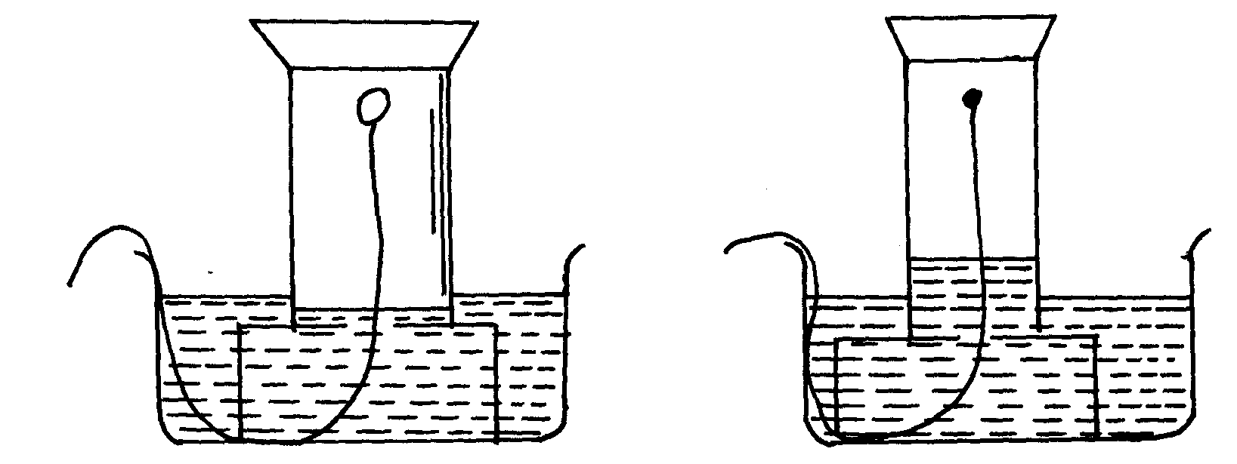
Gas jar
White phosphorous
Gas jar

Start of experiment End of experiment

(a) What was the aim of the experiment? (1mk)
…………………………………………………………………………………………………..
(b) Give the observations made. (1mk)
…………………………………………………………………………………………………..
…………………………………………………………………………………………………..
(c) Write an equation for the reaction that takes place in the gas jar. (1mk)
…………………………………………………………………………………………………..
…………………………………………………………………………………………………..
5. The set-up below was used to prepare the gas and investigate its properties
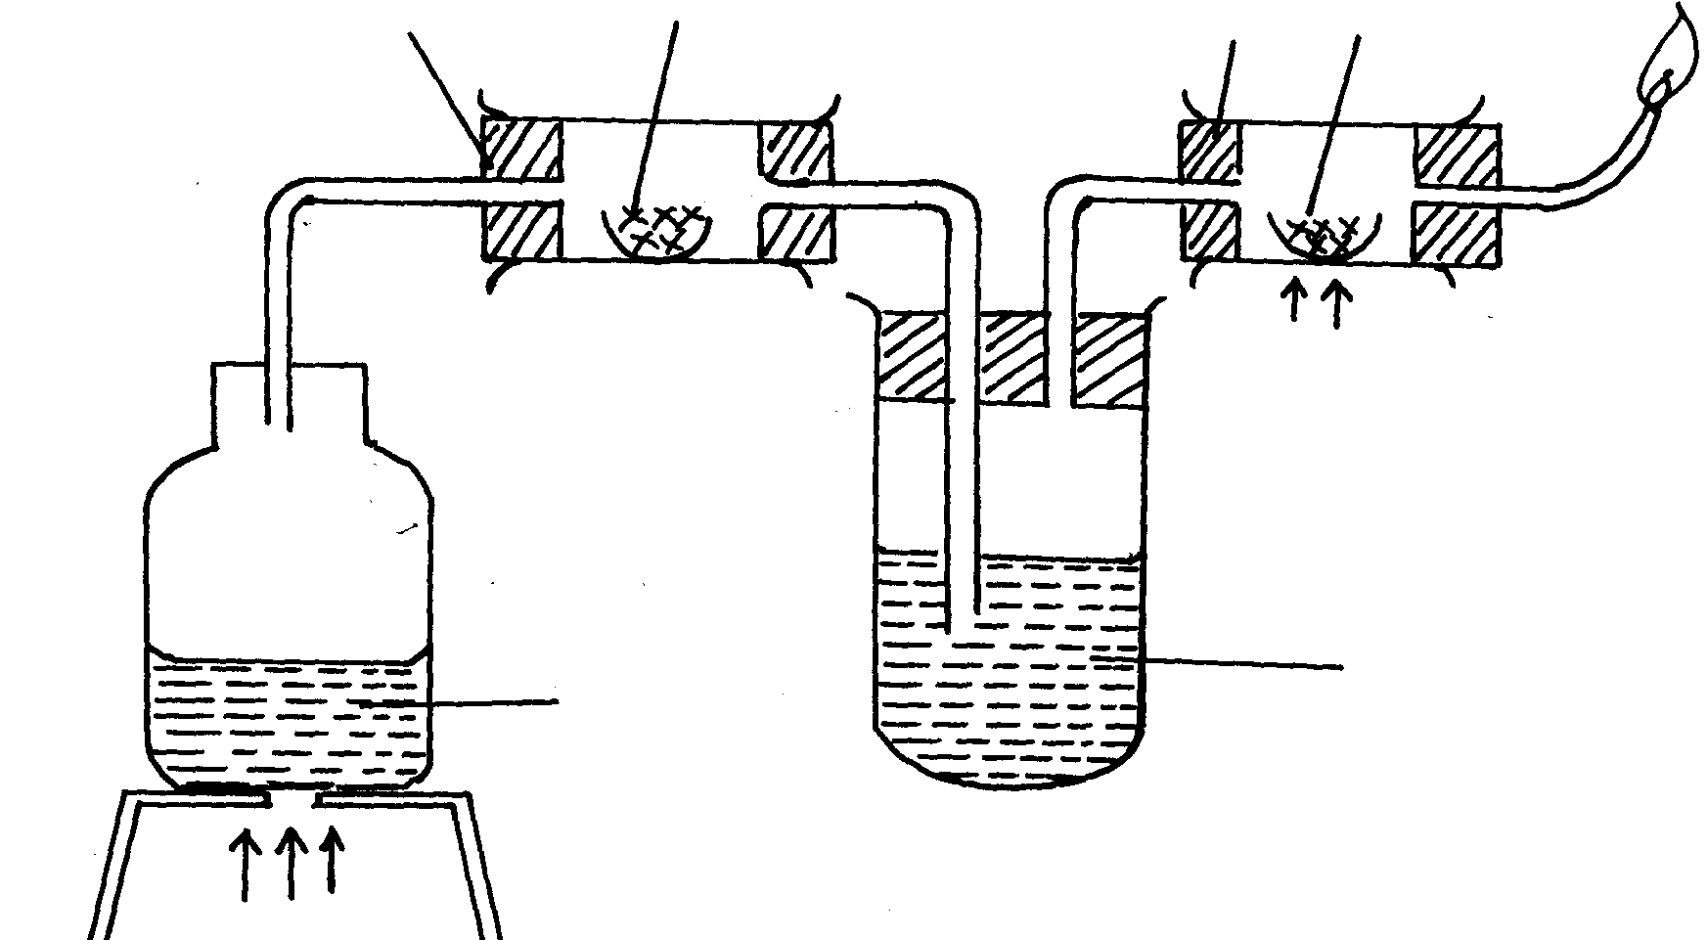
Magnesium ribbon
Lead (II) oxide
B
A
Gas burning

Heat
Heat

Liquid R
Water

Heat

(a) Write a chemical equation for the reaction in combustion tube A that leads to the formation
of the gas. (1mk)
…………………………………………………………………………………………………..
…………………………………………………………………………………………………..
(b) Identify liquid R. Why is it used? (1mk)
…………………………………………………………………………………………………..
…………………………………………………………………………………………………..
(c) State the observation made at the end of the reaction in combustion tube B. (1mk)
…………………………………………………………………………………………………..
…………………………………………………………………………………………………..
6. A given element E has atomic number of 14 and consists of isotopes as shown below;
Isotope | X | Y | Z
Isotopic mass | 28 | 29 | 30
Percentage abundance | 92.2 | 4.7 | 3.1
(a) What are isotopes? (1mk)
…………………………………………………………………………………………………..
…………………………………………………………………………………………………..
(b) Determine the relative atomic mass of E (2mks)

(c) State the position of element E in the periodic table (1mk)
…………………………………………………………………………………………………..
7. Study the information in the table and answer the questions that follow;
Element | Atomic No. | Electronic arrangement | Boiling point (ºC)
I | 3 |  | 1617
J | 13 |  | 2740
K | 17 |  | -34
L | 18 |  | -187
M | 19 |  | 1033
(a) Select elements which belong to the same group. (1mk)
…………………………………………………………………………………………………..
(b) Which elements are in the gaseous state at room temperature (25ºC). Explain. (2mks)
…………………………………………………………………………………………………..
…………………………………………………………………………………………………..
(c) Write the;-
(i) Formula of the carbonate of the element J. (1mk)
…………………………………………………………………………………………………..
(ii) Chemical equation for the reaction between the most reactive metal and the most reactive
non-metal. (1mk)
…………………………………………………………………………………………………..
…………………………………………………………………………………………………..
(d) Draw a dot (•) and cross (X) diagram for the compound formed between elements
I and K (2mks)

(e) (i) Complete the table above by filling in the electronic arrangements of all the elements.(2½mks)
(ii) Identify the chemical family to which element I belongs. (1mk)
…………………………………………………………………………………………………..
(f) Which elements form basic oxides? (1½mks)
…………………………………………………………………………………………………..
(g) List any two uses of element L. (2mks)
…………………………………………………………………………………………………..
…………………………………………………………………………………………………..
8. A mixture contains the three gases Ethene, Hydrogen and Ammonia;
Gas | Water | Concentrated H₂SO₄ | Concentrated NaOH
Ammonia  Hydrogen  Ethene | Very soluble  Slightly soluble  Slightly soluble | Very soluble  Insoluble  Soluble | Very soluble  Insoluble  Insoluble

(i) Explain how you would obtain a sample of hydrogen gas from a mixture of the three
gases. (3mks)
…………………………………………………………………………………………………..
…………………………………………………………………………………………………..
…………………………………………………………………………………………………..
…………………………………………………………………………………………………..
…………………………………………………………………………………………………..
9. Using dot (•) and cross (X) show the bonding in Carbon (II) oxide. (2mks)

10. The following table gives some information about the physical properties of substances
S, T,U and V. Use the information to answer the questions that follow;
Substance | M.pt (ºC) | Hardness | Electrical conductivity in solid state | Electrical conductivity in molten state
S | High | Hard/brittle | Good | Good
T | High | Hard/brittle | Poor | Poor
U | High | Hard/brittle | Poor | Good
V | Low | Soft | Poor | Poor

(a) Which of these substances exists as a;
(i) Giant covalent structure (1mk)
…………………………………………………………………………………………………..
(ii) Giant metallic structure (1mk)
…………………………………………………………………………………………………..
(iii) Giant ionic structure (1mk)
…………………………………………………………………………………………………..
(b) (i) Why is the melting point of V low? (2mks)
…………………………………………………………………………………………………..
…………………………………………………………………………………………………..
(ii) Why is U a good electrical conductor when in molten state and poor when in
solid state? (2mks)
…………………………………………………………………………………………………..
…………………………………………………………………………………………………..
(c) (i) Which substance would you recommend for making the cooking pan? Explain (2mks)
…………………………………………………………………………………………………..
…………………………………………………………………………………………………..
(ii) Name the substance that can be used in the laboratory as an electrolyte. (1mk)
…………………………………………………………………………………………………..
(iii) Study the structure below and answer the questions that follow;

H +
A
H – N – H
- B
H

Name the bond represented by A and B (2mks)
A…………………………………………………………………………………………………..
B…………………………………………………………………………………………………..
11. (a) Name two methods used to prepare soluble salts (2mks)
…………………………………………………………………………………………………..
…………………………………………………………………………………………………..
(b) (i) Write a chemical equation for the precipitation of Lead Chloride from Lead nitrate
and Sodium chloride. (1mk)
…………………………………………………………………………………………………..
…………………………………………………………………………………………………..
(ii) Give an ionic equation for the reaction in (b) above. (1mk)
…………………………………………………………………………………………………..
…………………………………………………………………………………………………..
12. The diagram below represents the electrolysis of molten lead (II) bromide
battery

Gas Y
Solid X ------------------------
Molten lead (II) bromide
Heat
(a) Name (2mks)
i) Solid X…………………………………………………………….
ii) Gas Y………………………………………………………………
b) Write ionic equations for the formation solid x and gas y (2mks)
Solid X…………………………………………………………………………………………………..
Gas Y……………………………………………………………………………………………..
c) On the diagram show the anode and the cathode (2mks)
(d) Give one precaution to be taken while carrying out the experiment (1mk)
…………………………………………………………………………………………………..
13. Give two properties of Carbon (IV) oxide that makes it suitable for use in fire extinguishers (2mks)
…………………………………………………………………………………………………..
…………………………………………………………………………………………………..
14. Copper (II) chloride solution and Copper metal are both conductors of electricity. Give two
differences in their mode of conduction (2mks)
…………………………………………………………………………………………………..
…………………………………………………………………………………………………..
…………………………………………………………………………………………………..
…………………………………………………………………………………………………..

15. Naturally occurring boron exists as two isotopes, boron-10 B with a relative abundance
10
5
10
5
of 20% and boron-11 B with a relative abundance of 80%.
(a) How many electrons does each atom of boron contain? (½mk)

(b) How many neutrons does each atom of the most abundant isotope contain? (1mk)

(c) Draw the electronic structure of the most abundant isotope of boron (2mks)

16. Name two halogens. (2mks)
…………………………………………………………………………………………………..
…………………………………………………………………………………………………..
17. Define the following terms;
(a) Hygroscopy (1mk)
…………………………………………………………………………………………………..
…………………………………………………………………………………………………..
(b) Atom (1mk)
…………………………………………………………………………………………………..
…………………………………………………………………………………………………..

18. The flow chart below shows how sodium carbonate is manufactured by the solvary process.
Study it and answer the questions that follow;

Limestone, solid A and Air
Chamber III
Solid B
Chamber I
Water
Gas P
Filtrate D
Chamber II
CaCl_{2(aq)}
Ammoniacal brine
Chamber IV
Solid R
Chamber V
Gas X
Ca(OH)_{2(aq)}

(a) Name the following substances; (3mks)
(i) Gas P ……………………………………………………………………………..
(ii) Gas X ……………………………………………………………………………..
(iii) Solid A ……………………………………………………………………………..
(iv) Solid B ……………………………………………………………………………..
(v) Filtrate D ……………………………………………………………………………..
(vi) Solid R ……………………………………………………………………………..
(b) Write chemical equations for the reactions that occur in;
(i) chamber I (1mk)
…………………………………………………………………………………………………..
…………………………………………………………………………………………………..
(ii) Chamber II (1mk)
…………………………………………………………………………………………………..
…………………………………………………………………………………………………..
(c) Name two gases that are recycled in the above process (2mks)
…………………………………………………………………………………………………..
…………………………………………………………………………………………………..
(d) Give one use of sodium carbonate (1mk)
…………………………………………………………………………………………………..

19. The figure below represents part of a periodic table. Study it and answer the questions that follow: (The letters do not represent the actual symbols of the elements)

P
T
K
M
X
A
I
II
III IV V VI VII
VIII

(i) What name is given t the group to which P and T belong? (1mk)
…………………………………………………………………………………………………..
(ii) Which letters represent non-metallic elements? (2mks)
…………………………………………………………………………………………………..
(iii) What type of bond is formed when P and X react? Explain (2mks)
…………………………………………………………………………………………………..
…………………………………………………………………………………………………..
(iv) Give the formula of the compound formed when element K and oxygen react. (1mk)
…………………………………………………………………………………………………..
(v) On the grid indicate with a tick the position of element Q that is in the second period of
the periodic table and form Q²⁻ ion. (1mk)
(vi) Write the formula of the oxide of M (1mk)
…………………………………………………………………………………………………..
20. The table below shows the products formed when nitrates of three metals were heated;

Nitrate | Products
U | Metal , Nitrogen (IV) oxide, Oxygen
V | Metal nitrite, Oxygen
W | Metal oxide, Nitrogen (IV) oxide, Oxygen

(a) Arrange the metals in order of increasing reactivity starting with the least reactive (1mk)
…………………………………………………………………………………………………..
(b) Give the formulae of two possible cations likely to be in Nitrate V (2mks)
…………………………………………………………………………………………………..
…………………………………………………………………………………………………..
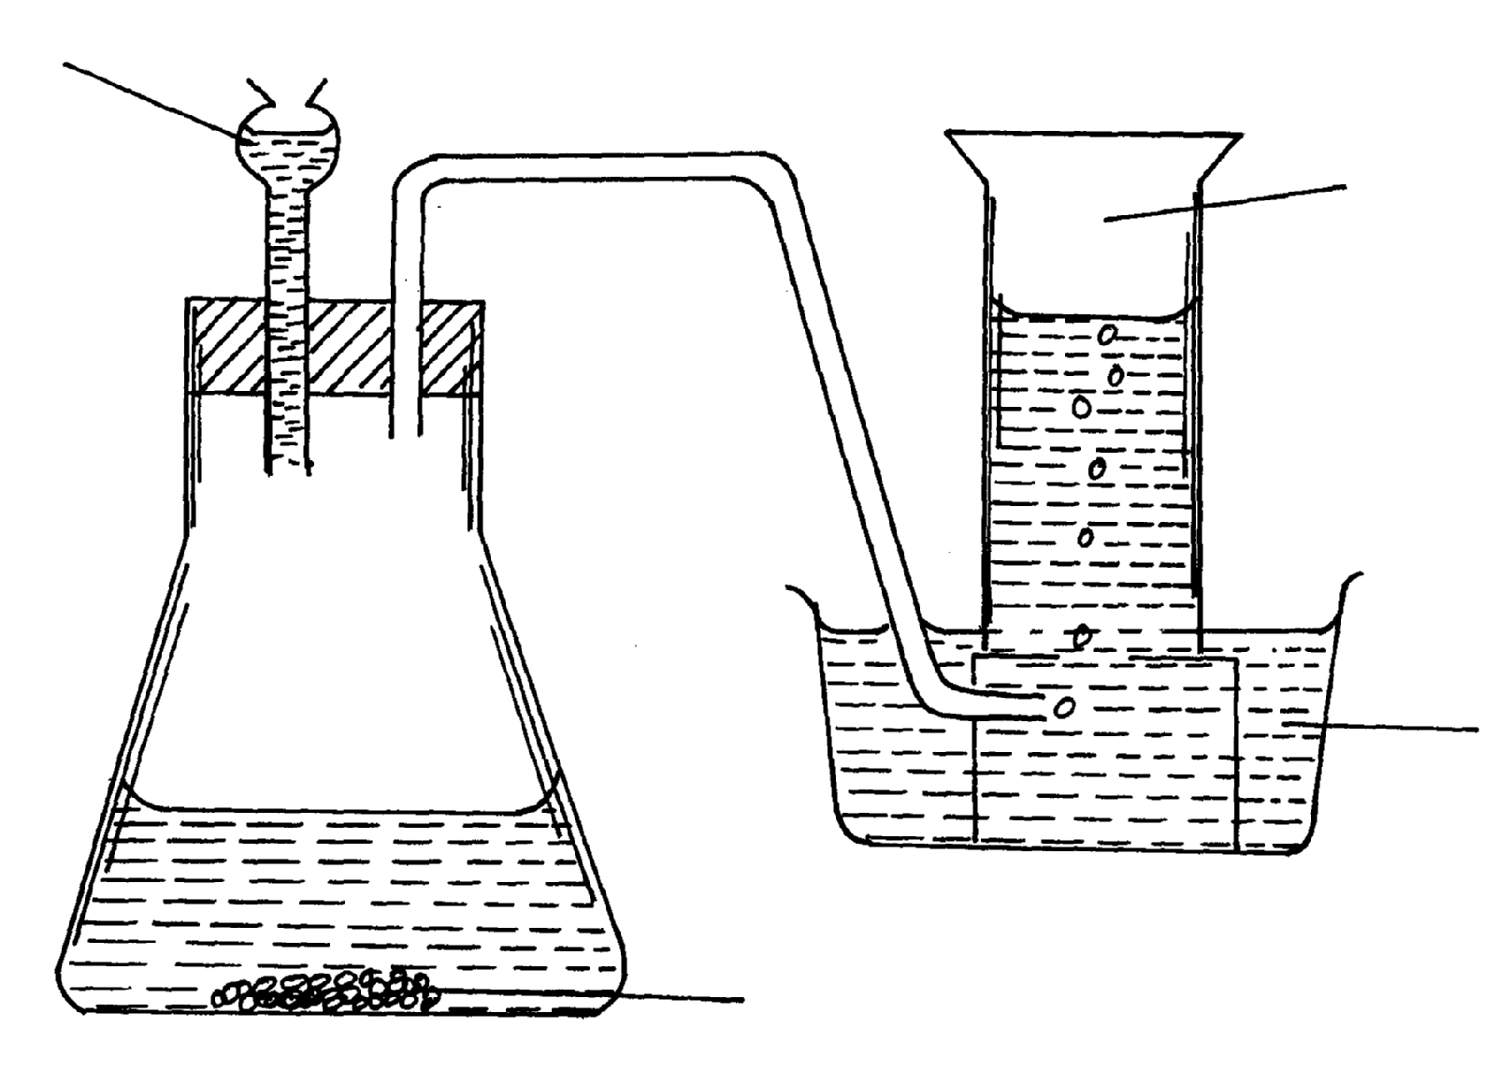
21. A student set-up the apparatus shown below to prepare a few jars of dry Carbon (IV) oxide;
Lead (II) cabornate
Water
Carbon (IV) oxide
H₂SO_{4(aq)}

(a) (i) Identify any three mistakes in the set-up (3mks)
…………………………………………………………………………………………………..
…………………………………………………………………………………………………..
…………………………………………………………………………………………………..

(ii) Write a chemical equation for the reaction above. (1mk)
…………………………………………………………………………………………………..
…………………………………………………………………………………………………..
(b) Explain the observation made when burning magnesium ribbon is lowered into a gas
jar containing dry carbon (IV) oxide (3mks)
…………………………………………………………………………………………………..
…………………………………………………………………………………………………..
…………………………………………………………………………………………………..
…………………………………………………………………………………………………..
…………………………………………………………………………………………………..
…………………………………………………………………………………………………..

