CHEMISTRY 233 MARKING SCHEME
1. (a)The almost colourless region contains unburned gases
(b) When the air hole is completely opened.
(c) – pale blue
-Very hot
-Noisy
-Non sooty

2. (a) (i) it allows water vapour to condense into liquid and flow back into the flask before the boiling
point of water is reached
(ii) To increase the surface area for condensation process
(b)- During oil refinery
- During the manufacture of Nitrogen and Oxygen gas.

3. (a) Universal indicator
(b) Weak acid
(c) It gives the strength of acid or base while others only indicate them as acids or bases

4. (a) To determine the fraction of air used up in burning
White fumes were produced by the phosphorous
- level of water in the gas jar rises
(c) 4P_{(s)} + SO_{2(g)} 2P₂O_{5(s)}
OR 4P_{(s)} + 3O_{2(g)} 2P₂O_{3(s)}

5. (a) H₂O_{(g)} + Mg_{(s)} MgO_{(s)} + H_{2(g)}
(b) Conc. H₂SO₄ – to dry te hydrogen gas
(c) Grey substance is formed

6. (a) Atoms with the same atomic number but different mass numbers
(b) (92.2 x 28) + (4.7 x 29) + (3.1 x 30)
92.2 + 4.7 + 3.1
25816 + 136.3 + 93.0
100
2810.9
100
= 28.109
(c) Period 3 Group IV
7. (a) I and M
(b) K and L. their boiling points are well below the room temperature (25oC)
(c) (i) J₂ (CO₃)₃
(ii) 2M_{(s)} + K_{2(g)} 2MK_{(s)}

(d) I – X K - •
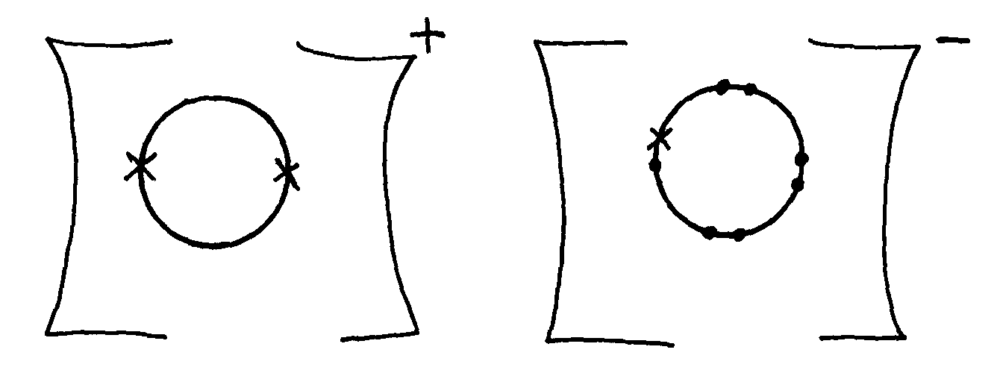

e) (i) I – 2:1 J – 2:8:3
K – 2:8:7 L - 2:8:8
M – 2:8:8:1
(ii) Alkali metals
(f) I or J or M
(g) – In light bulbs
- In forming inert atmosphere during welding

8. (i) – pass the moisture through conc. NaOH.
NH_{3(g)} – dissolves but H_{2(g)} and C₂H_{4(g}) does not
- Pass he remaining gases through conc. H₂SO₄; Ethene dissolves leaving H_{2(g)} which is collected by upward delivery.
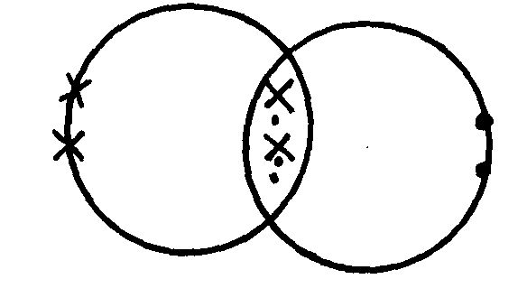
Key
C- X
O- •
9.

10. (a) (i) T (ii) S (iii) U
(b) (i) Atoms are held together by strong covalent bonds, but molecules are held together by weak
van der waal forces.
(ii) Ions are not free in solid state but free in molten state
(c) (i) S it is a good conductor and hard/brittle to match the cooking activities
(ii) U
(iii) A- Dative bond B- covalent bond

11. (a) – reaction of acids with metals
- reaction of acids with bases
- reaction of acids with carbonates
(b) (i) Pb(NO₃)_{2(aq)} + 2NaCl_{(aq)} PbCl_{2(s)} + 2NaNO_{3(aq)}
(ii) Pb²⁺_{(aq)} + 2Cl⁻_{(a}q) PbCl_{2(s)}

12. (a) S- Oxygen T – Hydrogen
(b) (i) 4OH⁻_{(aq)} 2H₂O_{(l)} + O_{2(g)} + 4e⁻
(ii) 2H⁺_{(aq)} + 2e⁻ H_{2(g)}
(c) Platinum

13. (i) Does not support combustion
(ii) Denser than air
14. - Copper metal uses electrons while Copper (II) chloride solution uses ions
- Copper metal is not decomposed while Copper (II) chloride is decomposed
15. (a) 5 electrons
(b) 11-5 = 6 neutrons
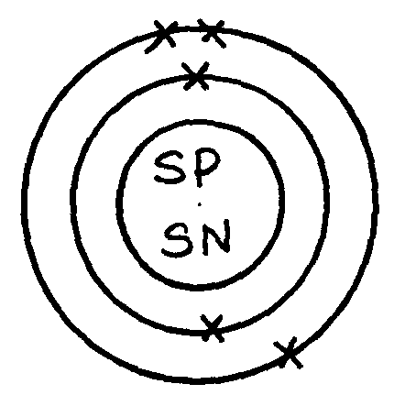
(c) ²⁰/₁₀₀ x 10 + ⁸⁰/₁₀₀ x 11 = 2+ 8.8 = 10.8
(d)

16. Chlorine, Iodine, Bromine, Fluorine (any tow)
17. (a) Hygroscopy – this a process in which some salts absorb water vapour but not enough to form
solutions
(b) Atom – smallest particle of an element that cannot exits on its own but take parts in a chemical
reacting
18. (a) (i) Ammonia
(ii) Carbon (IV) oxide
(iii) Carbon /coke/Graphite
(iv) Calcium oxide
(v) Ammonium chloride
(vi) Sodium hydrogen carbonate
(b) (i) Chamber I
CaO_{(s)} + H₂O_{(l)} Ca(OH)_{2(aq)}
Chamber II
2NH₄Cl_{(aq)} + Ca(OH)_{2(aq)} 2NH_{3(g)} + CaCl_{2(aq}) + 2H₂O_{(l)}
(c) – Ammonia
- Carbon (IV) oxide
(d) - manufacture of glass
- water softening

19. (i) Alkali metals
(ii) X and A
(iii) Ionic – Involve transfer of electrons
(iv) KO

X
A
I
II III IV V VI
VII
(v)

(vi) M₂O₃

20. (a) U, W, V
(b) Na⁺, K⁺

21. (a) (i) – Gas will escape since thistle funnel not dipped in the reacting mixture
- Lead (II) Carbonate not suitable since it will form insoluble Lead (II) sulphate with Sulphuric acid
- Drying agent has not been used yet Carbon (IV) oxide is required dry.
(ii) PbCO_{3(s)} + H₂SO_{4(aq)} PbSO_{4(s)} + CO_{2(g)} + H₂O_{(l)}
- continue burning forming white powder and black specks
(b) white powder due to formation of magnesium oxide
- Black specks because of carbon formed
2Mg_{(s)} + CO_{2(g)} 2MgO_{(s)} + C_{(s)}

