Name: ………………………………………………………………… Adm. No ……….........................

School: ……………………………………………………………. Candidate’s Sign……….....……

Date: ……………………………………………………………
BIOLOGY
(THEORY)
TIME: 2 HOURS

TERM 2 MID TERM 2 ASSESMENT EXAMINATION -2022

FORM 2
BIOLOGY

INSTRUCTIONS TO CANDIDATES:

- Write your name and your admission number in the spaces provided above.
- Sign and write the date of the examination in the spaces provided above.
- Answer all the questions in the spaces provided.

For Examiner’s Use Only:

QUESTIONS | MAXIMUM SCORE | CADNIDATE’S SCORE
1 – 30 | 100

1. The scientific name of the cat is Felis catus classify the cat into; (3mks)
i) Kingdom………………………………………
ii) Genus…………………………………………
iii) Species…………………………………………
2. Define the following branches of biology.
a) Ecology (1mk)
…………………………………………………………………………………………………………
b) Anatomy (1mk)
…………………………………………………………………………………………………………
3. State the functions of each of the following organelles.
a) Centrioles (1mk)
…………………………………………………………………………………………………………
b) Ribosomes (1mk)
…………………………………………………………………………………………………………
4. Name the Kingdom to which each of the following belong.
a) Spirogyra (1mk)
…………………………………………………………………………………………………………
b) Vibrio cholerae (1mk)
…………………………………………………………………………………………………………
c) Maize (1mk)
…………………………………………………………………………………………………………
5. The diagram below represents a cell organelle.
N
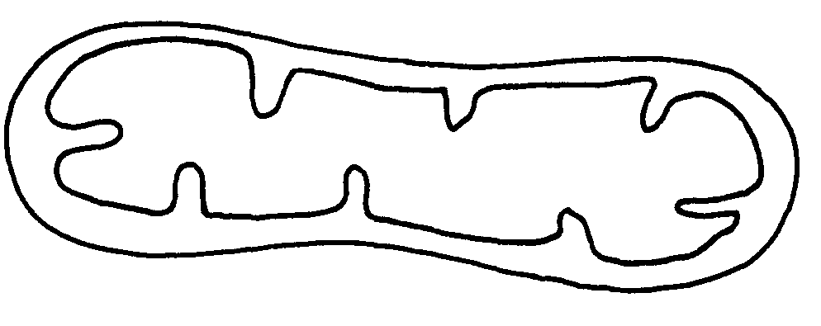
M

a) Identify the organelle. (1mk)
…………………………………………………………………………………………………………
b) Name the part labeled M. (1mk)
…………………………………………………………………………………………………………
c) State the function of the part labeled N. (1mk)
…………………………………………………………………………………………………………
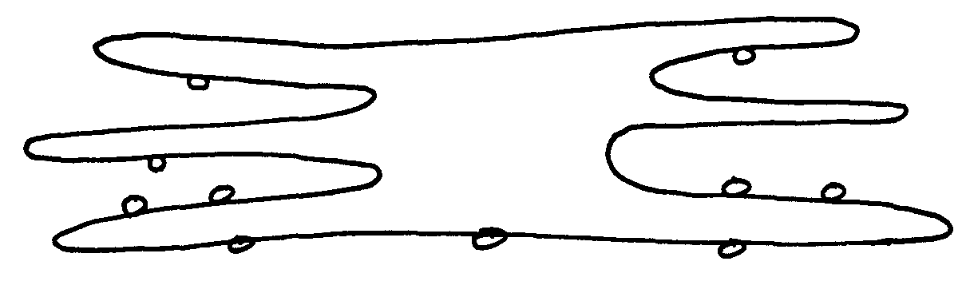
6. The organelle below was observed in a cell using a microscope.

a) Identify the organelle above. (1mk)
…………………………………………………………………………………………………………
b) On the diagram, label the part where protein synthesis occurs. (1mk)
…………………………………………………………………………………………………………
7. A form two students trying to estimate the size of onion epidermal cells observed the following
on the microscope’s field of view.
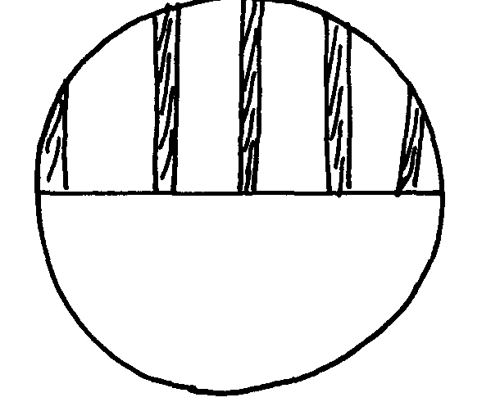

He counted 20 cells across the diameter of the field of view. Calculate the size of one cell in micrometers. (3mks)
…………………………………………………………………………………………………………
…………………………………………………………………………………………………………
…………………………………………………………………………………………………………
8. Explain the differences between turgor pressure and wall pressure. (4mks)
…………………………………………………………………………………………………………
…………………………………………………………………………………………………………
…………………………………………………………………………………………………………
…………………………………………………………………………………………………………
9. Distinguish between haemolysis and plasmolysis (4mks)
…………………………………………………………………………………………………………
…………………………………………………………………………………………………………
…………………………………………………………………………………………………………
…………………………………………………………………………………………………………
10. The diagram below shows how food moves along the human oesophagus and intestines
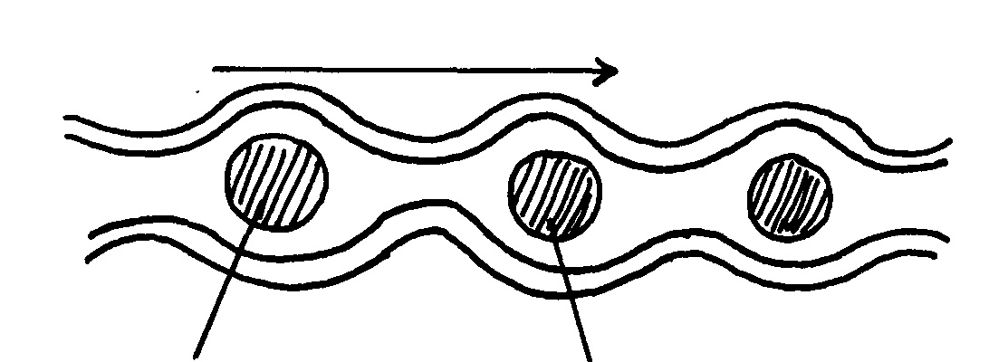
Movement
Position E₂
Position E₁

a) Identify the process illustrated in the diagram. (1mk)
…………………………………………………………………………………………………………
b) Explain the movement of the food bolus from position E₁ to position E₂ . (1mk)
…………………………………………………………………………………………………………

c) Name one component of the human diet that assist in the movement in (b) above. (1mk)
…………………………………………………………………………………………………………
11. Below is the structure of an organelle found in a plant.
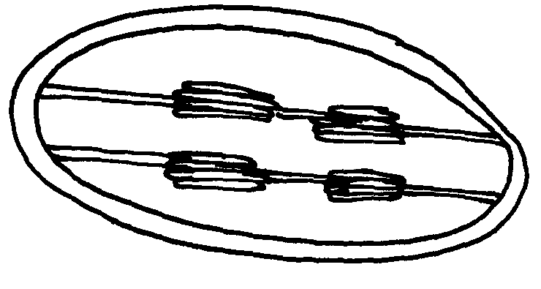

X

i) Name the organelle (1mk)
…………………………………………………………………………………………………………
ii) State the functions of the organelle named above. (1mk)
…………………………………………………………………………………………………………
iii) Name the part labeled X. (1mk)
…………………………………………………………………………………………………………
12. Suggest two functions of mucus secreted along the walls of the alimentary canal. (2mks)
…………………………………………………………………………………………………………
…………………………………………………………………………………………………………
13. Name three aspects of light that are important during photosynthesis. (3mks)
…………………………………………………………………………………………………………
…………………………………………………………………………………………………………
…………………………………………………………………………………………………………
14. The equation below shows a chemical reaction that takes place in green plants under certain conditions.
Carbon (IV) oxide + Water glucose + X
Name the;
i) Substance represented by X……………………………………………………………………(1mk)
ii) Process represented by the equation…………………………………………………………..(1mk)
15. a) Define the term symbiosis . (1mk)
…………………………………………………………………………………………………………
…………………………………………………………………………………………………………
b) What are the final products of digestion of fats. (2mks)
…………………………………………………………………………………………………………
…………………………………………………………………………………………………………

16. The diagram below shows a vertical section through amammalian heart.
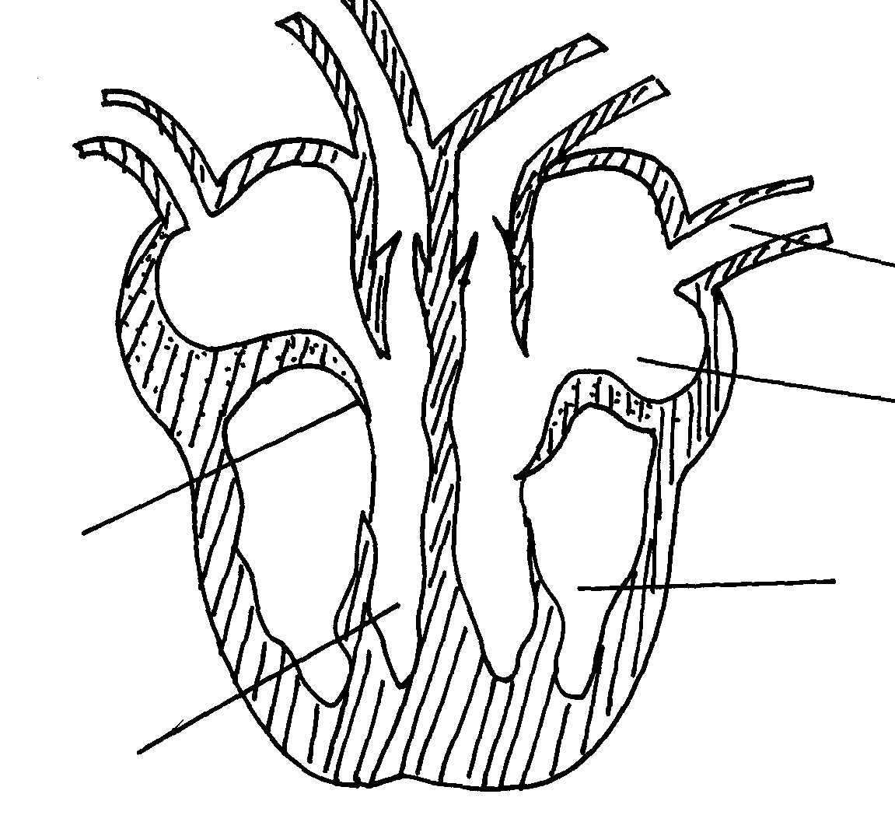
A
B
C
D
E

a) Name the parts labeled A to E (5mks)
A………………………… C………………………… E…………………………
B ………………………… D…………………………
b) Give a reason why the wall of chamber C is thicker than chamber D. (2mk)
…………………………………………………………………………………………………………
…………………………………………………………………………………………………………
17. The figure below represents a transverse section of a young root.
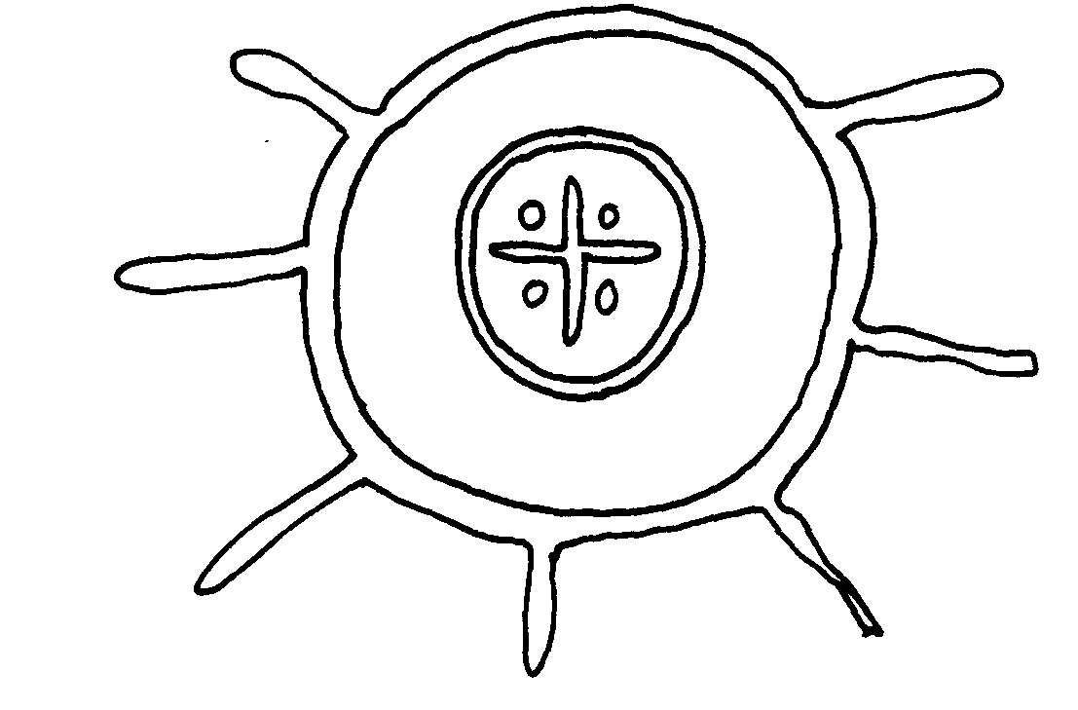
A
B

a) Name parts labeled A and B (2mks)
A…………………………………………………………..
B…………………………………………………………..
b) State the functions of parts labeled A and B (2mks)
A……………………………………………………………………………………………………
…………………………………………………………………………………………………………
B ………………………………………………………………………………………………………
…………………………………………………………………………………………………………
18. List three structural modifications of a leaf which enable plants to reduce water loss. (3mks)
…………………………………………………………………………………………………………
…………………………………………………………………………………………………………
…………………………………………………………………………………………………………

19. The following schematic diagram represents the main stages in the blood clotting process.
A
B
C
Fibrin
Prothrombin
Broken platelets release

a) Name the Substances A and C. (2mks)
A……………………………………………….
C………………………………………………...
20. State two ways in which the leaf is suited to gaseous exchange. ( 2mks)
…………………………………………………………………………………………………………
…………………………………………………………………………………………………………
21. Name two structures for gaseous exchange in amphibians (2mks)
…………………………………………………………………………………………………………
…………………………………………………………………………………………………………
22. The progress that occurs in plants is represented by the equation below:

C₆H₁₂O₆ 2C₂H₅OH + 2CO₂ + Energy.

a) Name the process (1mk)
…………………………………………………………………………………………………………
b) State three economic importance of the named process in (a) above. (3mks)
…………………………………………………………………………………………………………
…………………………………………………………………………………………………………
…………………………………………………………………………………………………………
23. State one role that is played by osmosis in;
i) Plants (1mk)
…………………………………………………………………………………………………………
ii)Animals (1mk)
…………………………………………………………………………………………………………
24. a) State three structural differences between arteries and veins in mammals . (3mks)
…………………………………………………………………………………………………………
…………………………………………………………………………………………………………
…………………………………………………………………………………………………………
b) Name a disease that causes thickening and hardening of arteries. (1mk)
…………………………………………………………………………………………………………
26 Name the deficiency diseases of each of the following nutrients . (7mks)
Vitamin A……………………………………….
Vitamin B………………………………………..
Vitamin B₂……………………………………….
Vitamin C………………………………………..
Vitamin D………………………………………..
Calcium………………………………………….
Iodine…………………………………………....
27. Explain how the red blood cells of mammals are adapted for efficient transport of
oxygen. (2mks)
…………………………………………………………………………………………………………
…………………………………………………………………………………………………………
28. a) What is the importance of gaseous exchange in plants. (2mks)
…………………………………………………………………………………………………………
…………………………………………………………………………………………………………
b) Name the three gaseous exchange structures in plants. (3mks)
…………………………………………………………………………………………………………
…………………………………………………………………………………………………………
…………………………………………………………………………………………………………
29. What are the respiratory structures in the following organisms. (5mks)
- Mammals…………………………………..
- Amoeba…………………………………….
- Fish…………………………………………
- Tadpoles……………………………………
- Insects……………………………………..
30. The diagram below represents apart of the rib cage.
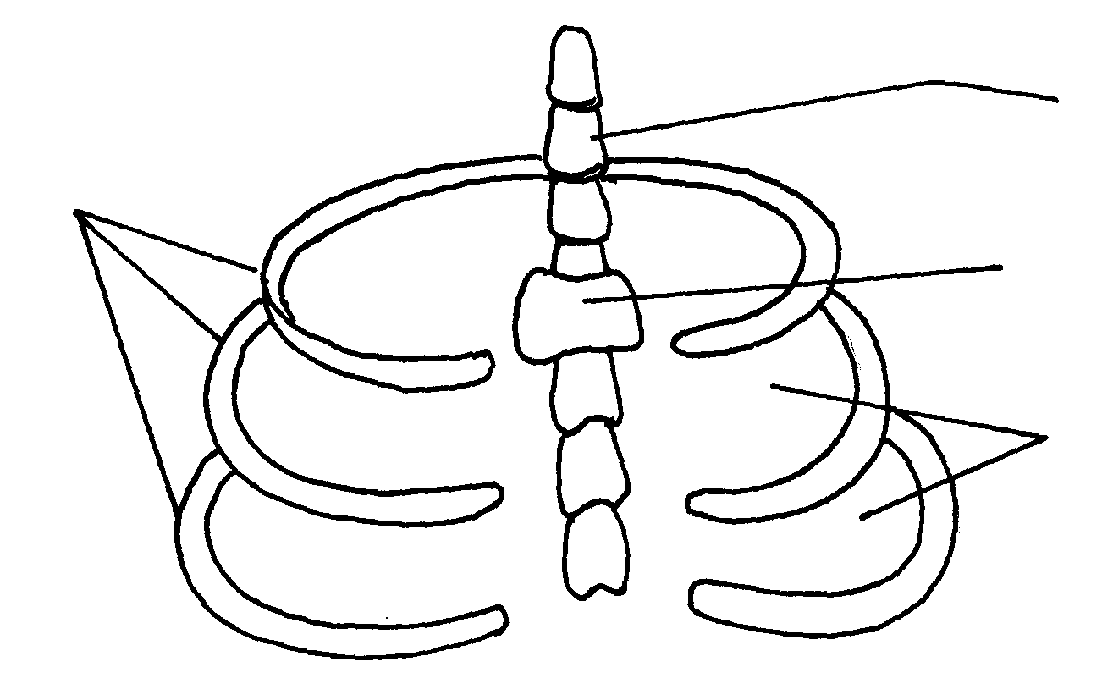
W
Z
Y
R

a) Name the bones labeled W,Y and R (3mks)
W……………………………………………….
Y………………………………………………..
R……………………………………………….
b) How does the part labeled Z facilitate breathing in? (3mks)
…………………………………………………………………………………………………………
…………………………………………………………………………………………………………
…………………………………………………………………………………………………………
c) State two characteristics of respiratory surfaces. (2mks)
…………………………………………………………………………………………………………
…………………………………………………………………………………………………………

